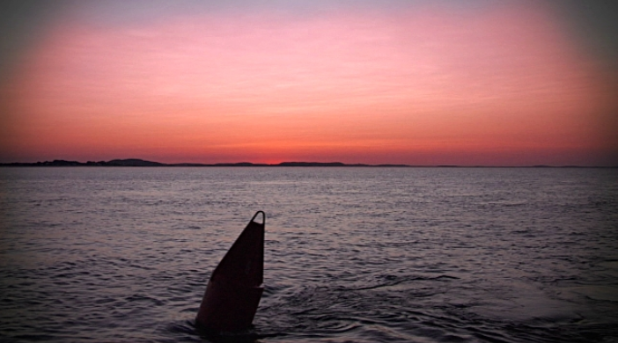

**HAPPY THANKSGIVING TO ALL**

**NAVIGATION SYSTEMS - 2017**

November Newsletter

Accuracy

Saving

**U.S. Coast Guard Auxiliary, First District, Northern Region**

**Thanks to all the First Northern Aid Verifiers who helped Navigation Systems make their Annual Objectives in 2017.**

**This is the fifth season in a row for this great First Northern Navigation Systems team to achieve their Annual PATON Objectives in conjunction with the various participating CG ANTs and DPW Staff in Boston.**

This year was a little different which is starting to become characteristic of each year. We had two Divisions who didn’t show up for work this year. One Division made their objectives with only two active AVs. And, as usual, Division NS Teams signed up to travel to other Divisions to assist. Many aids, that were previously observed with discrepancies, were rechecked and corrected. Overall, we are getting the more problematic aids corrected as our AVs are becoming more experienced dealing directly with the Harbormasters and owners. Also, in 2017, we were able to get more “unauthorized” PATONs permitted that in any previous seasons. We introduced the HMRAP – Harbormaster Ride Along Program – into additional areas this year.

Characteristically, our seasoned and reliable Aid Verifiers are becoming more knowledgeable and accurate. They are expanding their navigational skills into new areas and forming productive relationships with our PATON Owner partners and the Harbormasters. More cooperative activity is being developed between the owners, the Coast Guard ANT and the Auxiliary Aid Verifiers. The result is that many problems are being resolved quicker, more accurately and directly with much less administrative muddle that ever before. AVs are starting to take ownership of the private aids and bridges in their AOR and are following up on reported discrepancies in their area to insure that the problems actually get resolved. The bodes well for the future of this program.

Unfortunately, the number of available AVs have been dropping steadily for the last few years and our access to Auxiliary facilies is becoming worrisome. The ideal solution is to develop new AVs with access to operational facilities. Our annual Navigation Systems Training Programs presented each Spring using WebEX is focused on this basic AV training. It is becoming obvious that it is also necessary to expand the skills of our currently qualified AVs to enable them to handle HMRAP assignments. We also need to encourage experienced AVs to handle assignments with other Division locations. There are also solutions for remotes areas for AVs to conduct verifications and checks by phone directly with the PATON owners. For the future, I see an overall need for committed AVs who are able to handle a variety of different solutions in order to meet our annual Coast Guard objectives.

During 2017, the First Northern AVs conducted **1,176** verifications, **343** rechecks and permitted **145** “unauthorized” private aids to navigations. Also, so far **134** or **76%** of the First Northern bridges have been surveyed. Reports are still coming in. AVs who need to complete their two annual two verifications in order to maintain their currency should check out their local bridges on the Bridge Reporting System. Access is available on the D1 NR Navigation Systems Web Site at [www.uscgaan.com](http://www.uscgaan.com).

**The IMPACT of your USCG Auxiliary AUXDATA Reporting**

Every hour of your support to the Coast Guard that you report to AUXDATA means real dollars for the Coast Guard budget.  **AUX7029** reported hours are worth about **$11** and AUX7030 activity reported hours are worth close to **$22**. **This is a big deal**. Congressional support is only provided when the Coast Guard can present compelling evidence of that support. Our Auxiliary hours are included in that evidence.

Much of our Navigation Systems PATON and Bridge activity is performed underway on authorized patrols. These underway hours are reported by the Coxswain or Owner of the Auxiliary Facility. However there are a lot of additional hours incurred in support activity, especially by Navigation Systems Staff Officers.

We urge you to report any additional time expended in support of the Navigation Systems program via AUXDATA. This would include any planning for you patrol, aids and bridges performs when not under orders either by land or on the water, meetings with the NS Staff and CG, etc.

***Proper Coast Guard funding for our Auxiliary programs can be impacted.***

**The Navigation Systems AV Tag Line**

***Accuracy – Credibility - Professionalism – Timeliness and Service to the Coast Guard.***

***This is who we are!***

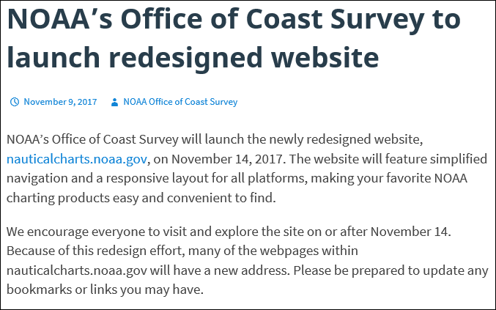

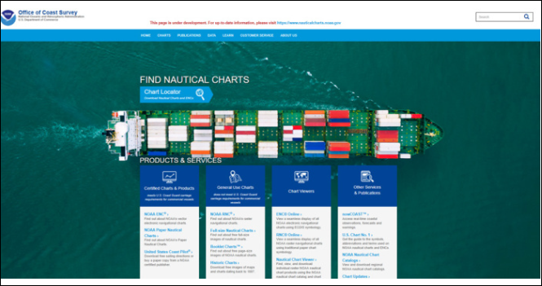

**The Annual PATON Program Planning Process explained!**

While the 2017 PATON season wanes, we are quickly swinging into the 2018 Private Aid planning and reviewing process which will continue throughout the winter and spring months. Our objective is to be ready to get underway in May of 2018. In the meantime, we will be identifying a series of “Recheck” tasks that we will be asking for your help to wrap up by May, 2018. This Planning process typically has five phases as explained below. ***Please read carefully. There are winter and spring tasks that you can complete to get your Run(s) ready for the work scheduled in the field this summer.***

**Phase 1 – Review of the Current Year**. **[Currently in process for 2017]**

In Phase One, all of the events for the current year are reviewed and updated to each Run Sheet in First Northern. The latest positions for each PATON in the Harbormaster System, the Light List and the NOAA charts are rechecked along with any CG-7054 PATON Reported data and all updates to the Harbormaster System by DPW-1 in Boston. In 2018, the RUN Sheets are revised to provide more room for entering the required field observations. As every trained AV knows, many private aids are not listed in the Light List nor are they charted. This is made clearly identified on the new Run Sheet. We were able to add a Navigation System Calculator capability so that when an Aid Verifier’ reports an observed LAT/LONG for an item on the Run Sheet, the distance that the observed position is located from the permitted position is calculated in feet and is shown on the Run Sheet. The system also compares the distance off with the “***Off Station Criteria***” listed for the PATON and reports whether the aid is on or off station. Also, the system still calculates and reports the aid’s “***Depth at Datum***” when the echo sounder depth and the HOT (estimated height of tide) is entered on the Run Sheet.

Phase 1 is designed to save AVs much time not having to reference the Harbormaster System and the Light List when working in the field. It also provides access to the latest historical data for each aid without the need to reference any other document(s). When Phase 1 is completed, the DSO-NS sends the RUN Sheet to the local AVs, the Coast Guard and in some situations to the Aid Owners. The Run Sheet is upgraded to Phase 2.

**Phase 2 – Local AV Review of each Run Sheet.**

Upon completion of each Run Sheet, it will be sent to the AVs who work in its AOR for the following review:

1. AVs are requested to check the ***sequence of the aids***. The objective is that the aids should be listed in the order that they would normally be encountered when transiting the area on a PATON Patrol. The objective is to minimise the handling of paperwork during the verification or checking process and to show the most efficient route for the patrol. The preliminary verification and checking plans are developed and reported during Phase 1.
2. AVs are requested to add any additional information to the RUN sheet that they feel needs to be referenced or observed during the following year while on-scene at the aid’s location.
3. AVs are asked to review the schedule and point any specific problems that will hinder their ability to handle the items scheduled for the following year, such as, inability to perform the assigned work due to lack of facilities or AVs or any other issue that may affect the program in this RUN’s AOR.
4. AVs need to add in any “unauthorized” PATONs located in the RUN’s AOR and indicate the aid’s position or the sequence that the aid should appear on the RUN sheet.
5. AVs should return their updated Run Sheet to the DSO-NS within three weeks of their receipt.

**Phase 3 – Updating period for the Harbormaster System Update**

1. The DSO-NS or designate will update data received from the field to the the PATON Run Sheet.
2. The DSO-NS or designate will update the Harbormaster System to reflect the private aids that are scheduled for verification in the coming year and insure that the Harbormaster System is a match to the items scheduled for verification on the RUN Sheet.
3. Important recheck information assignments will only be available on the PATON RUN Sheets.

**Phase 4 – The RUN Sheet is released to the Navigation Systems Staff**

1. Once Phase 3 is completed, the Run Sheet is released to the field. During this phase, commitments from the local ADSOs or SOs are requested by the DSO-NS. Local AVs may be assigned the scheduled rechecks at this time.
2. Many assigned rechecks can be completed with the Owner by phone or e-mail during the winter and spring months. It is recommended that this work be completed by the end of May prior to the start of the boating season.
3. Training will be covered in the AV Training Sessions each year.
4. AVs are asked to to e-mail the completion of rechecks to the the DSO-NS. Updated Run sheets can also be used for this purpose.
5. The DSO-NS will update the Run’s Phase to 5.
6. At this point, the DSO-NS will post the Navigation Systems Web Site this year under the heading, “RUN SHEETS,” making them available to any AV for download to their PC.

**Phase 5 – The Run is officially Scheduled for the Season and added to the Navigation Systems Web Site.**

Phase 5 designated Runs are theoretically in the hands of the local ADSO-NS and SO-NS. A tentative schedule has been assigned. Specific AVs should be assigned the field work at this time. Check with your local SO-NS or ADSO-NS for work assignments for a specific Run to avoid duplication of effort in the Division.

**Phase 6 – The RUN is completed for the year.**

During the boating season, Phase 6 is assigned to RUNs as they are completed in total – verifications, rechecks, photos and “Unauthorized” assignment are completed. The objective is to have all RUNs raised to Phase 6 on or before October 1 each year. Status reports are forwarded to the District Board at the end of each month from June through October.

* **Become part of the Planning.**
* **Take the initiative for action!**
* **Be part of the solutions to problems!**
* **Be active with the PATON teams in the field!**
* **Interface directly with the Coast Guard, the owners, and the Harbor Masters in First Northern.**
* **Move out of your comfort zone!**
* **Make it happen!**

**These are opportunities offered by Navigation Systems in 2018.**

Pass the word, Aid Verifier Training is scheduled to begin in February, 2018 on Webex.



*Under the Privacy Act of 1974, all information in this newsletter may only be used for official purposes. Any other use is a violation of law. This newsletter was prepared and published by the First Northern Navigation Systems Team. Contact the editor at* ***FrankJLarkin@verizon.net.***