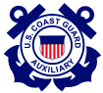 | United States Coast Guard Auxiliary
  First Northern
  Navigation Systems Team
  “We check the ATONs, PATONs, and bridges and
  update the charts of First Northern.”
YOUR FIRST NORTHERN  NAVIGATION SYSTEMS TEAM – Staff Officers  DSO-NS  Frank J. Larkin  FrankJLarkin@verizon.net - 978-263-3023  ADSO NS Boston_______________  Jeff James  sinbadtoo@verizon.net - 978-486-4346  SO-NS 3 - Rex Kelly  RexKelly@verizon.net - 978-352-5654  SO-NS 4 - Al Goldstein  RedHeadAFG@aol.com – 978-979-3121  SO-NS 5 – Anthony Silvestri  tiptony@msn.com - 781-326-0565  SO-NS 9 - Charles Lydon,  bellaboat@access-4-free.com  413-323-4870  SO-NS 12 - FrankSenkel  fwsenkel@hotmail.com - 784-848-6088  ADSO NS Woods Hole___________  Robert H. Nolan  Rnolan3579@aol.com - 508-420-1008  SO-NS 11 - Robert H. Nolan  Rnolan3579@aol.com - 508-420-1008  SO-NS 6 – Barry Novek  BNovek@comcast.net – 508-994-8206  ADSO NS Bristol, RI____________  Robert Pardi  Rapar8@juno.com - 401-647-3322  SO-NS 7 – Mike Quinn  MichaelSQuinn@gmail.com - 401-737-5078  SO-NS 8 - Frank Lucca  FLucca@comcast.net - 508-324-4576  SO-NS 10 - Sterling McClay  1bguy@charter.net – 508-476-3118  ADSO NS Northern New England_  Tom Raynor  tom@raynorshyn.com - 207-752-0296  SO-NS 1  Nancy Plunkett  Ku4uo@gwi.net – 207-230-1279  SO-NS 2  John Dempsey  JDempsey3@aol.com - 207-282-8223 | 2009 NAVIGATION SYSTEMS Program  ATON – Federal Short Range Aids to Navigation Program.  BAP - Bridge Administration Program.  PATON - Web-Based Private Aid Management Program.  CU - Chart Updating Program.  SCF – Small Craft Facility Updating Program.  2009 ATON Program - This Navigation Systems Division program encourages the checking of all Federal Aids to Navigation by every Auxiliarist while underway on a patrol. Nothing restricts a member from checking a Federal Aid and reporting observed discrepancies to the Coast Guard. “Qualified Auxiliarists and their facilities are authorized assignment to duty to support and augment the Coast Guard Aids to Navigation (ATON) Program. Auxiliarists may assist and support ANT Units in servicing Federal Aids after receiving proper Coast Guard training.” (Excerpted from Chapter 2, Section B.3 Aids to Navigation of the Auxiliary Manual.)  The focus of the ATON - Federal Short Range Aid to Navigation program is on accuracy, credibility, professionalism and service to the Coast Guard, and is directed toward building the competency level and professional view of the Auxiliary in the eyes of Coast Guard. New guidelines are available for taking fixes and depths, involving pre-underway and on-scene validation of all measuring equipment, credible high-quality on-site observations and measurements, and Professional on-line report preparation. Fixes are taken with GPS sets using WAAS or DGPS. Depths are taken with echo sounders and are corrected to the charted vertical datum. Also the observations of each aid are validated against the data for the aid in the latest version of the Light List, the Coast Pilot and the abbreviations and symbols on the NOS Nautical Chart.
  Accuracy
  Credibility
  Professionalism
  Service
______________________________________________________________________________

The 2009 USCG Auxiliary Bridge Program

The First Northern On-Line Bridge Discrepancy Reporting System was further updated again in 2008. A new web address security system was added. Change your bridge web address now to:
www.uscgauxnh.org/bridges/logon.

You need to check your E-Directory logon and data because you have to be able to logon to the Bridge Database without a current E-Directory address. This upgrade was needed to secure and limit access to the Bridge Discrepancy Reporting System.

The Bridge Discrepancy Reporting System has recently been upgraded to accept photographs for each bridge. This helps members verify that they are reporting the correct bridge. Some bridge records already have photographic updates.

The PowerPoint Bridge Training Presentation has been completed which can easily help make you an expert on bridge safety equipment. Other training documents have also been created and are available on the NS Bridge Web Page at www.uscgaan.com/. These new on-line features are:

First, access to the Bridge Discrepancy Reporting System is now controlled through the Auxiliary e-Directory.

Second, Upon submission, each member’s bridge report is automatically submitted on-line to the Bridge Program Manager (currently, the DSO-NS 1NR) from the member’s home personal computer.

Third, upon acceptance and update to a bridge’s record, another message is e-mailed back to the reporting member. With the click on a button, a bridge report can be rejected back to Auxiliary reporter for corrective action and resubmission, saving much administrative, mailing and communication time.

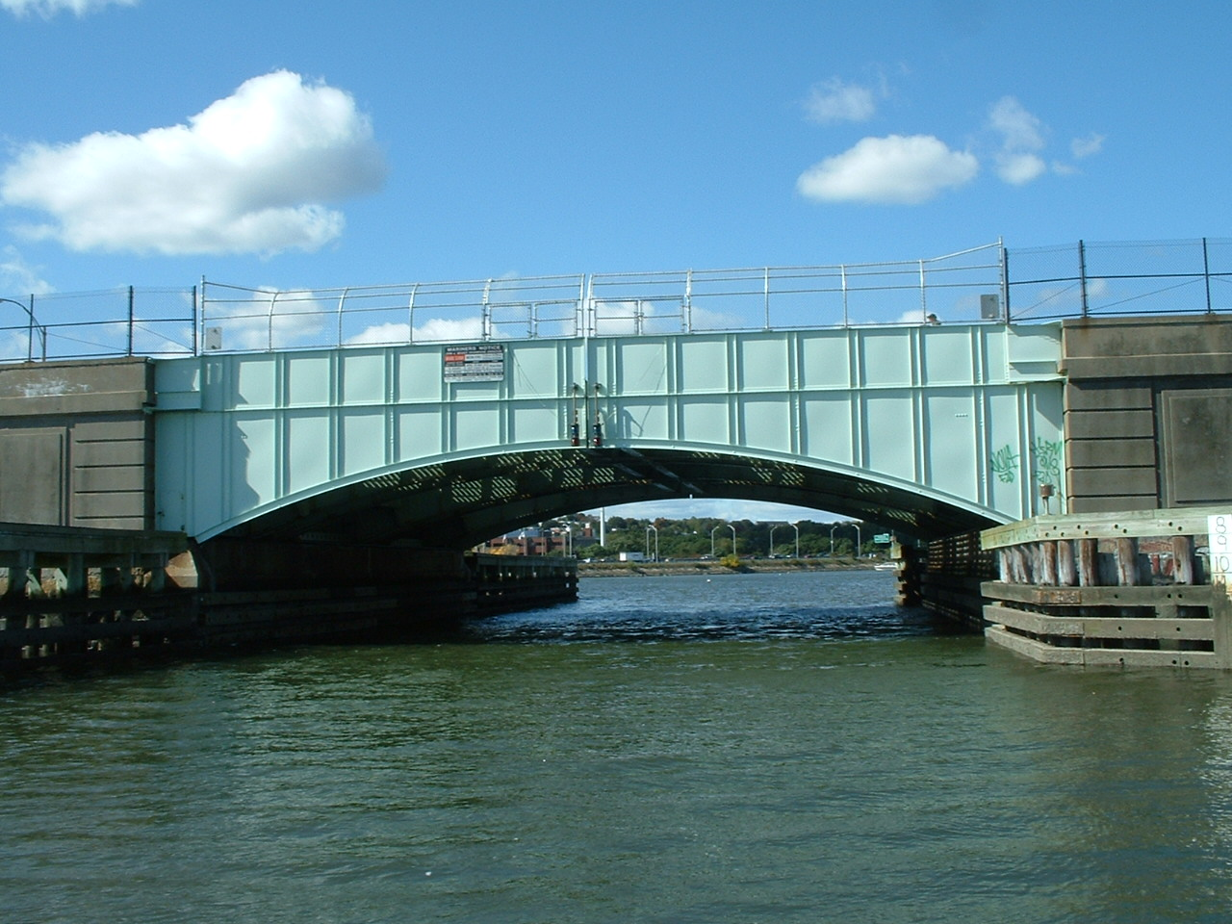

The Morrissey Blvd Bridge in Dorchester MA was one of the bridges checked and photographed by the Division 5 Navigation Systems Team this summer. It took five years to get the channel dredged under this bridge. Patience and persistence are important character traits for a good bridge checker.

Fourth, the Bridge Discrepancy Reporting System also notifies the Coast Guard Bridge Branch Manager in New York electronically who now use this same system to log when corrective action letters are sent to the bridge owners. More savings in paper, stamps and envelops are achieved as well major time improvements in the reporting cycle.

All Auxiliarists are encouraged to become aware of potential bridge lighting and safety equipment problems, to check every bridge that they pass, and to report every discrepancy that they observe to the Coast Guard Bridge Branch on the Bridge Discrepancy Reporting System.

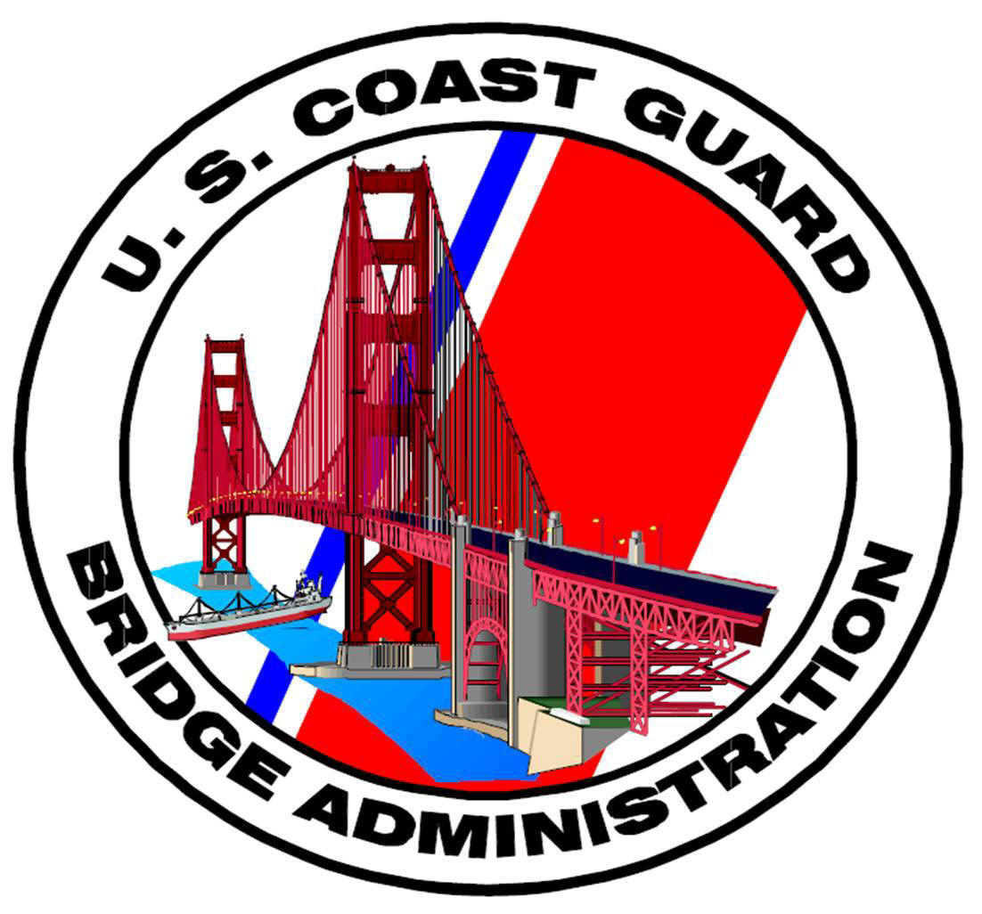

Web-Based
PATON
MANAGEMENT
SYSTEM

This new approach connects all the PATON program participants on-line, in a system that virtually eliminates the paperwork, reporting delays, envelops, stamps and report waiting time. The typical participants include the PATON owner, the DPW, the CG ANT, the Auxiliary AVs, and the harbormasters. This on-line system controls the process, the communications network and the approval sequences. Auxiliary AVs print out their “verification” reports from their home computers, and, after on-scene verification of the PATON, enter their observations on-line from their home computer. Immediately upon submission, the CG ANT and the DPW receive the AV reports on-line. In addition, the CG ANT is able to communicate any problem on-line to the PATON owner for correction. Once installed, this system can run itself and is a perfect fit for Coast Guard Auxiliary support. This system is currently used in the First Coast Guard District.
Auxiliary AV-Aid Verifiers must be qualified. The AV qualification study guide can be found on the PATON Web Page at www.uscgaan.com.
Once qualified, an AV can register on the system, request access to the PATON system and begin verifying private aids.
Currently, we have a PATON System upgrade project in process. The re-programming specifications have been written and presented to the CG DPW 1 for review and approval. The scope of this project involves upgrades to the existing system screen to:
- Insure that all fields are properly identified and available on each screen
- Identify each field as either required or optional.
- Update and insert drop-down menus on fields to standardize and control the data entry into these fields.
- Format certain fields to control the data entry.
- Minimize the need to re-enter data in a field that is already available in the user’s registration record.
Meetings are planned in December to finalize the project plan for this upgrade..

CU – Auxiliary/NOAA Chart Updating Program

If you are looking for a hobby that you can perform all year round, updating charts may be your cup of tea. Every nautical chart in New England is in need of review and there are plenty of updating opportunities available for all participants.

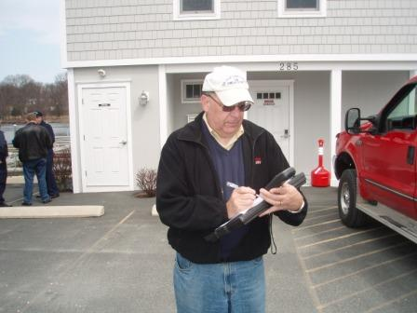

Besides upgrading your navigation skills, chart updating provides a great sense of satisfaction. Actually, you are the experts because of your access and familiarity with your local boating area.

The CU Program has been completely revamped and upgraded. A new CU Study Guide is available and new forms and worksheets have been developed. PowerPoint training programs are available on line at www.uscgaan.com.

The goals of the CU Program are to insure the accuracy of the investigation, to increase the credibility of the Auxiliary in the eyes of NOAA and to provide professional reports, loaded with evidence to support your recommendations. Our recent submissions are resulting in actual updates to NOAA charts due to this new problem-solving approach.

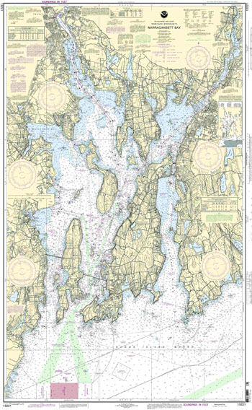

If you are interested in this program, contact your ADSO-NS. You may report on any NOS chart anywhere in the country. Every Division is encouraged to form an Auxiliary Division Chart Updating Team. Check the CU Web Page at www.uscgaan.com for more information about chart updating. If no one in your Division has formed a CU Team yet, take the initiative and start one yourself.



2009 - SCF–Small Craft Facility Updating Program

The source of many chart updating opportunities are often initiated from a SCF- Small Craft Facility update report. The initial SFC visit usually leads to the a chart update visit to a facility often kicks off further chart updating opportunities in the area, such as shorelines, ramps, other marine facilities, non-permitted private aids, bridges, obstructions, uncharted docks and new or removed structures.

The SCF Updating Program has been completely revamped and upgraded. A new study guide and a new form is available. PowerPoint training programs are provided on line on the SCF web page at www.uscgaan.com.

If you are interested in this program, contact your ADSO-NS. SCF activity should be coordinated with your Division Chart Updating Team. If your Division does not have a CU/SCF Team, form one.

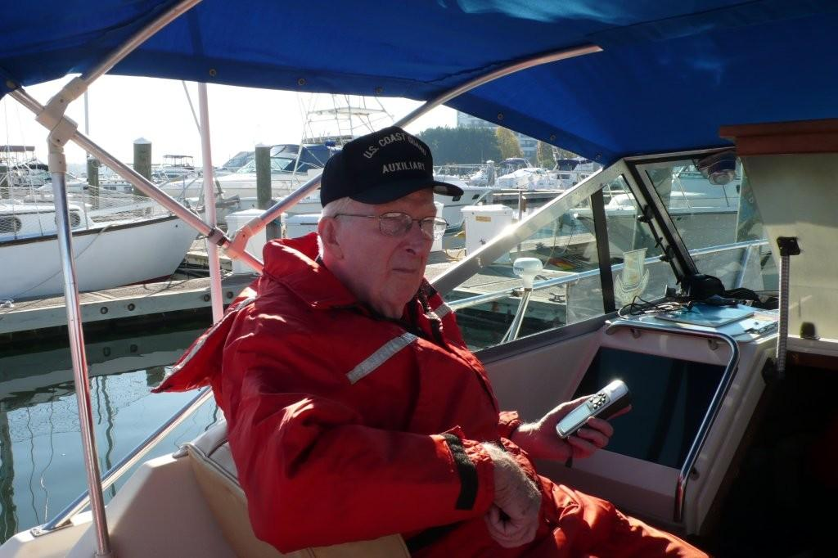
DSO-NS Frank Larkin on a PATON / Chart Updating patrol in mid October in Division 5. Training patrols are conducted in Boston Harbor all season long—June to October.

NS-Navigation Systems is the new designation for ATON/CU program.

Starting in 2009, the AN designation for the Aid to Navigation staff function is changing to NS for Navigation Systems Division. National Auxiliary has approved this change.

NS
Navigation Systems

NS - Navigation Systems - Tune Up Workshop
Saturday morning, January 3, 2009
0830 - 1200

Plan to attend this NS-Navigation Systems event at the January Conference and get updated with the ATON, PATON, Bridge, Chart Updating and Small Craft Facility Programs for 2009. You made a large impact in 2008 and we expect even better results for 2009. Every Auxiliarist is invited to join the First Northern Navigation Systems Team and this workshop is a great place to start. We encourage every NS staff officer to attend this workshop.

Workshop Agenda

ATON PROGRAM - Federal Short Range Aids to Navigation topics.
Discussion will include: How to use the new guidelines for taking and reporting Fixes and Depths to increase your accuracy, credibility and service to the Coast Guard; How to use the “ATON Discrepancy Report” available on the D1NR AN Web Site at www.uscgaan.com with the focus on your professional reporting; Why we submit discrepancy reports to the Coast Guard.

PATON PROGRAM - Private Aids to
Navigation.
The planned upgrade to the Web-based
PATON Management System will be
explained. The focus of this effort is to save
you time and improve the information
provided to the Coast Guard. Additional
discussion will include: How to properly
verify a PATON and submit an AV PATON
Report; How to correctly report a non
permitted aid; How to get involved with
the direct support needs at a Coast Guard
Aid to Navigation Team (ANT).

BAP - Bridge Administration Program.
Focus is on: How to submit Bridge Photos for the Bridge Database Report; The importance of submitting photos of all bridge discrepancies with the focus on the credibility and usefulness of your report to the Coast Guard; How to take and document effective photos of bridge discrepancies; The importance of reviewing a bridge’s discrepancy history in order to provide a more complete Bridge Report.

CU - Chart Updating Program
Topics include: -- What type of personality makes for the best Chart Update Reporter; How to form a Division Chart Updating Team. How many members are enough; How to complete simple Chart Updating area surveys; Supporting your report recommendations with evidence.

SCF - Small Craft Facility Reporting
This presentation includes -- Understanding the simplicity of the SCF activity. -- How to conduct a SCF interview using the new SCF Worksheet. -- Gathering the proper evidence and documents for NOAA.

Submitting 7030 Activity Reports - Mission for NS Program activity.
Topics are: How your 7030 Mission Activity Reports affect the Navigation Systems Division Program. -- How to prepare and transmit a 7030 report – taking less than a minute. -- Understanding why your activity is the important part of your 7030 report. –District NS Annual Awards – how the points are awarded and counted.

This NS workshop is an intensive three and a half hour experience. Come ready to ask those questions that have been bothering you about the Navigation Systems programs. We will have the experts available to provide you with the answers.

Every Coast Guard Auxiliary facility (OPFAC) should check and verify each ATON, PATON and BRIDGE for discrepancies that they pass, and observe charted features along the shoreline while underway.

AV & NE Qualifications and
ICS 210 and 300.

Per CHDIRAUX office – The AV-Aid Verifier and NE - Aid to Navigation technician qualifications are not required to take the ICS 210 or 300 courses to remain qualified but it is highly recommended.

Annual NS Activity Calendar

JANUARY

Plan to attend the January Conference to get a leg up on the upcoming year.

If you are relieving an NS Staff Officer at any level, be sure to get all the records and materials of your new office from your predecessor. If you have not received them as yet, make arrangements get the records transferred to you as soon as possible.

Referencing the District Goals, FSO-NSs, SO-NSs, and ADSO-NSs should set your Navigation System Program Goals for the upcoming year based on last years results.

- Secure a copy of the list of the current NS Staff Officers. Remind them to check whether their E-mail addresses are correct in AUXDATA. Send the corrections to your SO/IS. Also, please send any corrections to the DSO-NS at FrankJLarkin@verizon.net

- Start working on your Navigation Systems Program. If you have a problem, contact your SO-NS, ADSO NS, or DSO-NS for assistance. Your NS Program should include:
- Federal Aid (ATON) Checking Program.
- Private Aid (PATON) Verification Program (Must be AV-qualified to participate)
- Bridge (BAP) Administration Program
- Small Craft Facility (SCF) Updating Program.
- Chart Updating (CU) Program.

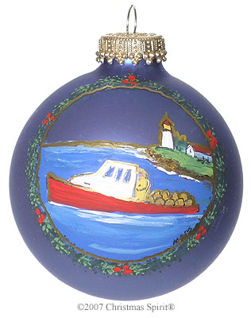
- AUXDATA updating procedure.
- Check out the ATON/CU Website www.uscgaan.com/ for training aids and procedures.

- If you are not receiving the Navigation Systems Newsletter, E-mail the DSO-NS at FrankJLarkin@verizon.net to get on the mailing list.

- The First Northern Bridge Database at www.uscgauxnh.org/bridges/logon Familiarize yourself with the Bridge Program.

- Remind your ATON Program volunteers that Bridge Checking, Small Craft Facility Updating, and Chart Updating can be performed all year round.

- Think Parallel Staffing when organizing your NS Program. To avoid putting the workload on one individual, try to organize your Flotilla FSO-NSs into parallel program responsibilities. If you have five flotillas within a Division, assign each FSO an NS-Program coordination responsibility—Federal Aids, Bridges, Private Aids, Adopt-a-Chart, and Small Craft Facility Checking.

To all our Navigation System Team members:

The key to our success in the Navigation Systems programs rests with people like you, who embody the spirit of greatness by saying, "Yes we can!" this year.
Thank you for your dedication and inspiring example during 2008.

Frank Larkin, DSO-NS 013



Under the Privacy Act of 1974, all information in this newsletter may only be used for official purposes. Any other use in a violation of law.
This newsletter was prepared and published by the First Northern Navigation Systems Team .
FrankJLarkin@verizon.net
Distribution is encouraged to other members of the Coast Guard and Auxiliary

