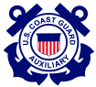 | United States Coast Guard Auxiliary  PREVENTION (Marine Safety) DEPARTMENT  NAVIGATION SYSTEMS DIVISION
AN MONTHLY REPORT 08-04
FIRST NORTHERN AID TO NAVIGATION TEAM
June, 2008

This newsletter is distributed to all Division Captains, Vice Captains and all Aid to Navigation Staff Officers. Please distribute to all your members.

The Call is out for active AVs in Division One.

Senior Chief Chris St.Martin of CG ANT Southwest Harbor is anxious to get the Division One PATON (Private Aid) program activated. Currently, there are 168 Private Aids in this AOR. There are nine AV-Aid Verifiers listed in AUXDATA:
013-01-02–Richard Ozog.
013-01-04–Lawrence Closson, Francis Kinsey, Billie Lear, Steen Meryweather, and Mark Smith.
013-01-05–Charles Helmboldt, Kalevi Oittinen, and Nancy Plunkett.

Nancy Plunkett, the SO-AN 013-01 is coordinating the program with Senior Chief St.Martin. CG ANT SWH is currently reviewing the PATONs and preparing the verification list for the 2008 season. The plan is to begin the program using PATON Verification Reports printed from I-ATONIS and transition to the new Web-Based PATON System during the season. AVs will be trained on this new system and be provided with access codes and passwords to logon to the PATON system from their personal computer.

AVs who plan to participate in this program should contact SO-AN Nancy Plunkett at ku4uo@gwi.net or at 207-230-1279.

Members who want to participate in the PATON Program must be AV-Aid Verifier Qualified. Download the AV Qualification Guide from the D1NR Aid to Navigation Web Site at www.uscgaan.com/ . Click on the PATON page. There is a PATON Study Guide on this site to assist you with your study. Any existing AV may act as a mentor. When completed, contact Nancy Plunkett for arrangements for final check-off.

The PATON program provides needed service to the Coast Guard. The local CG ANT Chief runs the program in their AOR. Reports are made directly to the Coast Guard. Also, there are additional service opportunities at the CG ANT maintaining the PATON files. As you gain experience and credibility working with the Coast Guard, you will be allowed to assume additional responsibility for the PATON program duties. Currently, ANTs Wood Hole, Bristol and Boston are served by skilled Auxiliarists. There is no reason why the Auxiliary can’t run the PATON program for a CG ANT. It only takes a little effort to build a mutual relationship with your CG ANT.

Division One Completes their 2008 Bridge Program

Thanks to the new SO-AN in Division One, Nancy Plunkett, all 78 of the bridges located in the Division have been checked and reported. These bridges have been classified, entered in the Bridge Database, with all discrepancies reported to the Bridge Branch in New York. What an incredible job! Also, the DSO-AN was presented with pictures of each bridge. Nancy deserves special thanks for her incredible effort on this project. She has demonstrated her leadership abilities and her intense desire to assist the Coast Guard. She earned her AV Qualification at the April Award Conference held in Nashua NH in April and became Boat Crew qualified last Saturday. Please give Nancy Plunkett your support and assistance as she tackles the Private Aid Program for Division one.

ADSO-AN Tom Raynor completes an upgrade of the on-line D1NR Bridge Reporting System

It seems that Sector NNE is getting all the kudos in this newsletter. ADSO-AN Tom Raynor, a member of Division 2, completed an upgrade of the Bridge Database. Some of the highlights of the new changes are:
- Front end security for logon to the Bridge Database through the E-Directory.
- E-mail to the Bridge Database Manager that a report has been submitted.
- Acknowledgement e-mail to reporter when the bridge report is reviewed and accepted on the Bridge Database. System also reports to the Bridge Branch by e-mail showing reported discrepancies.
- Rejection e-mail to reporter when the bridge report has been reviewed and required additional information and/or corrective action. Database is not updated at this time.
- Bridge database history update by Bridge Branch when owner is notified of a reported discrepancy.
- Bridge database history update by Bridge Branch when notified by owner that discrepancy has been corrected.
Tom has prepared this reporting system to be easily transferrable to other Districts. First Southern has implemented a similar system. This project was completed using superior programming skills and a strong dedication for providing service to the Coast Guard. The turnaround on Bridge Reports is now counted in hours and minutes rather than weeks and months as was the case just a few years ago.

You are invited to review the bridge database at www.uscgauxnh.org/aton/

If you are interested in assisting with the Bridge program, logon on to the First Northern Web Site at www.uscgaan.com/ Click on the Bridge Page to review the training aids available for your use.

Aid to Navigation PA Opportunities being scheduled at Long Island Light in Boston Harbor

So far we have three, possibly five Public Relations opportunities available this summer at Long Island Light in Boston Harbor. The Quincy Bay Beach Association has requested a tour of Long Island Light and the new summer camp on Long Island has requested a two-day event with instruction on the history of Long Island and Long Island Light. This camp is provided for local school children as a learning experience. We will be looking for volunteers to coordinate and supervise these programs.

Since Division 5 has adopted Long Island Light, we will be looking for a crew to landscape the area and clean up the light house facility. This event should be scheduled in late May or early June. Tony Silvestri, SO-AN 05 is the coordinator of this project. Members of other adjacent Divisions are invited to participate.

Volunteers are requested to contact Frank Larkin at FrankJLarkin@verizon.net. Lunch is always provided by the Camp. We usually operate from 1000 to 1600.

Attention Boat-Crew Members!
Make your operational patrols more meaningful this season. Add ATON, PATON, Bridges, Charts and Small Craft Facilities to your patrol plans. You’ll be amazed how the time will fly by, how much you will learn about your AOR and how much you will contribute to the Coast Guard, NOAA and your fellow mariners. We don’t want to be the only ones having all the fun. Contact your SO-AN for more information.

It’s time to get out and join the fun. We have hundreds of Federal Aids, Private Aids, Bridges, Small Craft Facilities and Chart Updating opportunities waiting for you.

For training materials, check out www.uscgaan.com/ .

For the Bridge Database, check out www.uscgauxnh.org/aton/ .

For Flotilla and Division training sessions, contact your ADSO-AN or the DSO-AN.

Get a strong sense of satisfactions by helping the Coast Guard through the Aid to Navigation / Chart Updating Program.

Who says NOAA Charts don’t get updated?

NOAA just released an updated Small Craft Chart 13221 for Narragansett Bay. Two years ago Mike Quinn had contacted the US Board of Geographic names to have Mary’s Creek designated as the official name of this small inlet just outside Apponaug Cove in Narraganset Bay. At the same time Division 7 performed a Chart Update on Greenwich Bay Marina which is right next to the Mary’s Creek. Both the new official creek name and new dock layout of Greenwich Bay Marina as well as the Small Craft Information has been updated on the new edition of the chart 13221.

Mike followed the new guidelines for Chart Updating and Small Craft Facility reporting and used the new forms and worksheets that can be found on th4 Chart Updating and Small Craft Facility reporting web-pages on the First Northern AN Web Site at www.uscgaan.com/ .

Now that we all have proof that NOAA uses our CU and SCF submissions as long as it’s credible and accurate, let’s get out there and form your Division Chart Updating Team. There are hundreds of opportunities to be found on the First Northern charts. Download and read the Chart Updating Study Guide and review the PowerPoint training presentation on our web site to learn how to submit credible, professional reports.

As always, if you have any questions, the First Northern Aid to Navigation Team is just an email or phone call away.

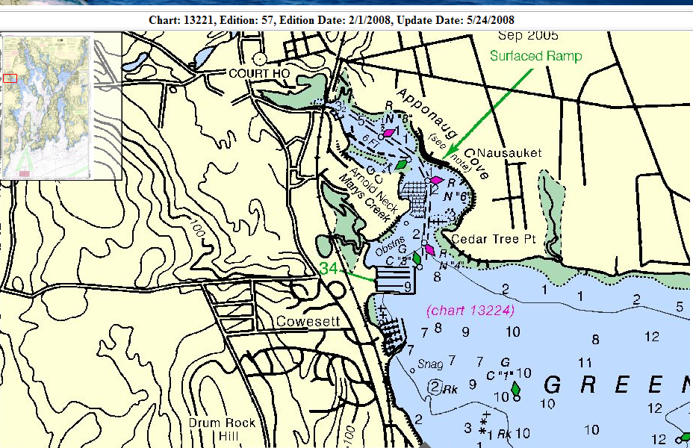
There are more reports in the hopper at NOAA, we will let you know when these changes appear on NOAA Charts. If you follow the new guidelines, you can make changes happen.

NOTE to all AN Staff Officers:

June is the time to execute your ATON/CU Program for 2008. This is when you get the job done?

Executing your plan is essential! Without a plan, nothing ever gets done. As AN Staff Officers, you must provide the leadership to get the ATONs, PATONs, Bridges, Small Craft Facility checks and Chart Updates done this summer. The Coast Guard is depending on you to get this important job accomplished.

JUNE AN STAFF OFFICER ACTIVITY CHECK LIST


Here are the AN Tasks that you should be reviewing with your team members during May. Include the progress that you make as part of your monthly AN report.

□ Schedule and conduct ATON, PATON, and Chart Updating patrols. Your ATON Program plan should be in full swing at this time.

□ Continue to encourage your volunteers to perform their assigned PATON and Bridge verifications.

□ Encourage your volunteers to perform Small Craft Facility Updating – especially those assigned to bridges as well as MV qualified members.

□ Get interested AN and AV volunteers underway on OPFACs for on-the-job training on Federal Aids and Bridges.

□ This is the time for execution. Get out there and start observing and reporting.

During 2008, we have a lot of ATON/CU work to do:
Federal ATON checks - 1,497, 11 reported completed to date.
PATON verifications - 2,156, 31 completed to date.
Bridges safety checks - 286, 90 checked to date.
Chart Updates 56, 0 submitted to date. (1 in process)
Small Craft Facility Updates 33, 2 completed to date.

Every Auxiliarist, while underway on an OPFAC, should be checking every ATON, PATON and Bridge that they encounter for discrepancies, and also be checking the shoreline for charting errors as well as providing update reports on all Small Craft Facilities in their AOR.

Check out the First Northern Aid to Navigation Web Site at www.uscgaan.com for anything you need to know about our program. Send us a digital photo for our “ATONers in Action” web page.

Please distribute this newsletter to other members of the Coast Guard and Coast Guard Auxiliary.
Under the Privacy Act of 1974, all information in this newsletter may only be used for official purposes. Any other use is a violation of law. This newsletter was prepared and published by the First Northern Aid to Navigation Team –DSO-AN 1NR.
Distribution of this Newsletter to other members of the Coast Guard and Auxiliary is encouraged.

