

**The 2018 Aid Verifier Training Schedule**

|  |  |
| --- | --- |
| **WEBEX LOG ON** instructions are available on Page 14.  The D1NR Web Site is available at [www.uscgaan.com](http://www.uscgaan.com). | E-mail the DSO-NS at [FrankJLarkin@verizon.net](mailto:FrankJLarkin@verizon.net) if you want to become AV Qualified in First Northern. |

**GETTING READY FOR A 2018 AV CHALLENGE?**

**AID VERIFIER** By completing this 2018 *Aid Verifier* (AV) course of study, you will be able to perform highly accurate *private aid to navigation* (PATON) verifications and rechecks on the First Northern’s private aids and be able to survey our bridges. You can form your own *Navigation Systems* (NS) Team or you may work as an individual contributor or possibly work directly with a Harbormaster or owner in the *HMRAP* (Harbormaster Ride Along Program). Whichever route you choose, you can become a skilled navigator and an important part of our AV support for the local *Coast Guard Aid to Navigation Team* (CGANT). There are approximately **2,500 private** **aids** in First Northern that the Coast Guard has directed the Auxiliary AVs to verify at a rate of one third (***approximately 833 private aids***) annually. Many other aids, with unresolved discrepancies, may be scheduled for re-check. Still more “unauthorized” aids may need to be researched for ownership and proper permitting. All official CG-7054 PATON Reports to the Coast Guard and aid owner are submitted on-line from your home on a personal computer. Run Sheets will be published on the NS Web Site for each Division in First Northern for this purpose.

The 2018 AV Training Program schedule is presented below. Open/CPN NOAA Charts are provided on line and all needed Coast Guard Nautical catalogs are linked on-line and are free. You can become a more skillful and knowledgeable navigator as the result of this specialized training.

With the limited availability of Auxiliary vessels, there are opportunities for new and existing AVs to participate in the ***HMRAP* – Harbormaster Ride along Program**.

**You are required to be Aid Verifier Qualified and current in order to perform verifications on private aids to navigation and surveys on bridges for the Coast Guard ANTs.**

**BRIDGE SURVEYOR -** There are approximately **170 bridges** scattered throughout First Northern. As part of the AV Qualification process, you will be trained to check the lighting and other safety equipment on these bridges. Our annual CG assignment is to survey every bridge within First Northern annually. All survey reports are screened and communicated to the Coast Guard Bridge Branch using on-line reports from your home computer. Bridge activity can be performed either by land or by boat. The Auxiliary AV’s are dispatched to check all of the bridges in First Northern each year.

**PRIVATE AID PHOTOGRAPHER** - Do you like to take photos? If so, this could be the project for you. *You don’t have to be AV Qualified to perform this task* and there are approximately **1,000 PATONs** waiting to be photographed in the First District this year. After a brief training session, you will be ready to help us update the remaining photo records in the Harbormaster System. We use low pixel photos that are cropped and clearly identified to their private aid counterparts. The PATON photo schedule is viewable on Run Sheets for each Division.

**NS:** NS stands for ***Navigation Systems*** and we need your assistance this year. If you are detail oriented and like to work with a GPS, Echo Sounder, Computer, Navigation Software and are capable of preparing detailed and highly accurate, professional reports, don’t miss out on this interesting volunteer opportunity.

IF YOU ARE WONDERING WHETHER YOU NEED TO TAKE THIS TRAINING, TRY TO COMPLETE “AV TRAINING 10” ON PAGE ELEVEN. You make the decision. You need to get 95% to pass. Current AVs who pass this section will be upgraded to AV/PQS.

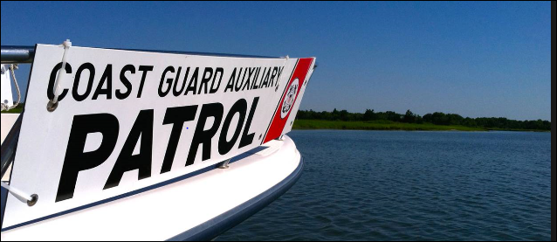

***The 2018 AV Training Schedule***

The D1NR Navigation Systems 2018 training program begins on Tuesday, February 6th on WebEX. Expand your navigation experience by joining these Navigation Systems training sessions. There’s room for 200 participants at each session. Recordings of each training session are maintained on the Navigation Systems Web Site for review by AVs and AVCs who unable to attend the live sessions.

**AV TRAINING 1 – INTRODUCTION TO NAVIGATION SYSTEMS**

**Tuesday, February 6, 2018 @ 2000 to 2130 hrs.**

***Pre-Class Assignments*:** You need to have copies of these documents available to follow along with this presentation.

* Download and review a copy of the AV/PQS from NS Web Site at [WWW.USCGAAN.COM](http://WWW.USCGAAN.COM) prior to this training session.
* Download and review a copy of the District Specific Tasks from NS Web Site [WWW.USCGAAN.COM](http://WWW.USCGAAN.COM) prior to this session.

***Presentation Topics:***

* (1) WebEX Orientation Session. The new procedure will be explained.
* (2) Orientation of the Navigation Systems Web Site. [Everything that you need to know about Aids to Navigation and Bridges is available on this Web Site.]
* (3) Understanding the AV Qualification Process.
* (4) Review of the AV/PQS.
* (5) Review of the required District Specific Tasks.
* **(6) HMRAP** – Harbormaster Ride Along Program is explained.

***Homework Assignments* to be completed before attending AV Training 2 session.**

* Find the following Nautical Catalogs and Almanacs on the D1NR Web Site (www.uscgaan.com). Familiarize yourself with their purpose and the information provided by each publication. Note that they are all free.
* **Corrected Light List (**Don’t download. This document is corrected weekly. Reference the Web Site copy.
* **LNM – Local Notice to Mariners. (**Don’t download. New issues are provided each week. Sign up for weekly e-mail or reference the Web Site.) AVs should read this document each week.
* **Chart No.1** (Download to your PC and review.)
* **Corrected Coast Pilot. (**Don’t download. This document is corrected every Tuesday**.** Reference the web site copy**.)**
* **The Navigation Systems Calculator.** (Download to your PC.)
* Read **Part 66** **of the Federal Regulations for Private Aids to Navigation** available of the Private Aids web page at [WWW.USCGAAN.COM](http://WWW.USCGAAN.COM) (Review this document before the AV Training @ session.?

|  |  |  |  |
| --- | --- | --- | --- |
|  |  |  |  |

**AV TRAINING 2 – NAUTICAL ALMANACS – FEDERAL REGULATIONS – INTRO TO ON-LINE NOAA CHARTS**

**Tuesday, February 20, 2018 @ 2000 to 2130 hrs.**

***Question and Answer Session on Training Session 1 Topics and Homework.***

***Presentation Topics***

* **Introduction to the free and on-line Nautical Almanacs used by AVs**

Review of the following documents on the NS Web Site at [WWW.USCGAAN.COM](http://WWW.USCGAAN.COM) . These are the reference documents that AVs use to check the published information about private aids and bridges. The District Staff use these documents to establish and check data, and each AV references these documents as part of their verification, recheck and survey activity.

* **The Harbormaster Private Aid to Navigation System.**
* **Corrected Light List**
* **LNM-Local Notice to Mariners**
* **Chart No. 1**
* **Corrected Coast Pilot**
* **The Navigation Systems Calculator**
* **Understanding the Federal Regulations for Private Aids to Navigation (PATONs).**

**Part 66** **of the Federal Regulations for Private Aids to Navigation,** available on the Private Aids web page at [WWW.USCGAAN.COM](http://WWW.USCGAAN.COM), are the rules and regulations that every AV needs to know in order to make knowledgeable observations and decisions for their proper use of private aids in the field.

* **An Introduction to NOAA Nautical Charts and the OpenCPN Chart viewer system**.

Check out the various Nautical Chart packages that are available on the NS Web Site at [WWW.USCGAAN.COM](http://WWW.USCGAAN.COM). This training is a comprehensive experience of all of the important elements of a NOAA Nautical Chart which are basic to your effectiveness as an Aid Verifier. Being able to correctly measure and plot private aids on electronic nautical charts is an important part of the AV skill set.

***Homework Assignments:***

* Obtain and read a copy of the “***Aid to Navigation Bookle***t” from your Flotilla Supply Officer or Public Education Officer or download it from the NS website here: [U.S. AtoN Booklet](http://www.uscgaan.com/cd/ATON/US_ATON_Book.PDF)

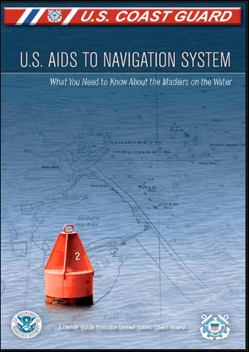

**AV TRAINING 3 – INTRO TO THE AID TO NAVIGATION SYSTEM – INTRO TO THE OPEN/CPN NOAA ON-LINE CHART SYSTEM.**

**Tuesday, March 13, 2018 @ 2000 to 2200 hrs.**

***Question and Answer Session on Training Session 2 Topics.***

***Presentation Topics***

* **Basic Aid to Navigation (ATON) Training Presentation**

This session deals with the specifications and physical aspects of private aids to navigation and their uses. AVs use this information for every private aid that they verify and check as an Aid Verifier.

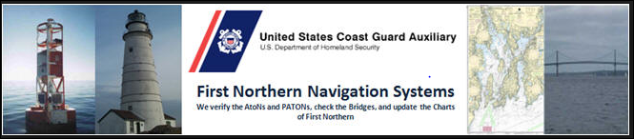

**AV TRAINING 4 –** **DISCREPANCIES ON AIDS TO NAVIGATION AND OTHER BUOYS AND STRUCTURES.**

**Tuesday, March 20, 2018 @ 2000 to 2200 hrs.**

***Question and Answer Session on Training Session 3 Topics.***

***Presentation Topics:***

* **A brief Introduction to the use of Open/CPN NOAA on-line charts by Mike Quinn**

This important session introduces you to the Open/CPN NOAA Charts that AVs need using when verifying and checking private aids.

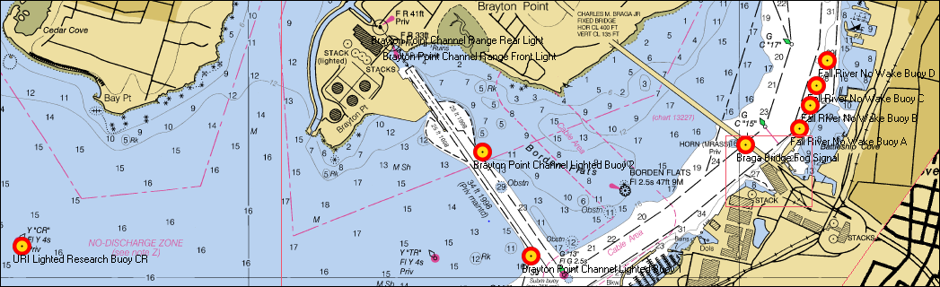

* **Private Aid to Navigation (PATON) Discrepancy Training**.

This session deals with the various issues that AVs will have to deal with regarding reporting discrepancies on private aids to navigation.

***Homework Assignment:***

* Request a copy of a local Run Sheet from the DSO-NS by e-mail and start to familiarize yourself with it before the next session**. Run Sheets are only available to AVs who support the First Northern Coast Guard**.

**AV TRAINING 5 –** USING THE PATON RUN SHEET– OPERATIONAL SOP FOR PERFORMING VERIFICATION ON A PRIVATE AID.

**Tuesday, March 27, 2018 @ 2000 to 2200 hrs.**

***Question and Answer Session on Training Session 4 Topics.***

***Presentation Topics:***

* **How to use the new PATON Run Sheet.**

Run Sheets are used in the field for collecting the required observations for scheduled private aid verifications and checks.

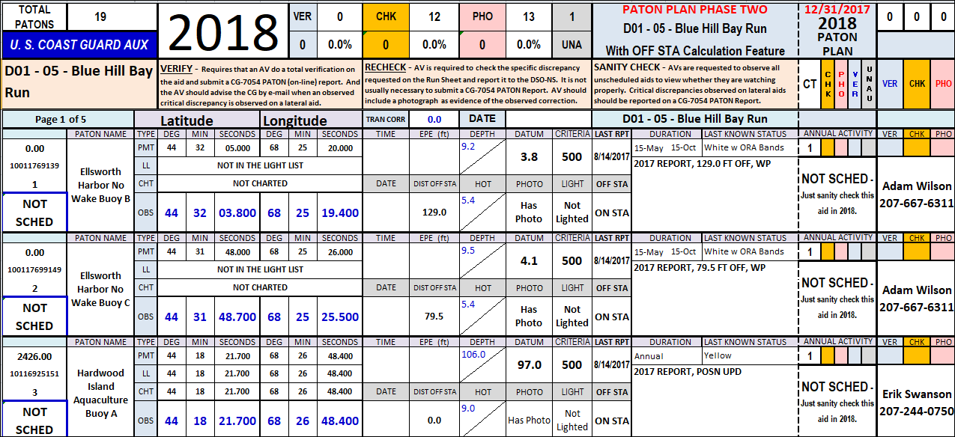

* **Operational SOP for performing a scheduled Triennial verification or recheck on a Private Aid.**

This critical training session explains the Standard Operating Procedure for verifying private aids to navigation in the field from the pre-underway check at the dock to the submission of the CG-7054 PATON Report on the on-line Harbormaster System. ***This procedure is required and must be followed for properly verifying a private aid to navigation.***

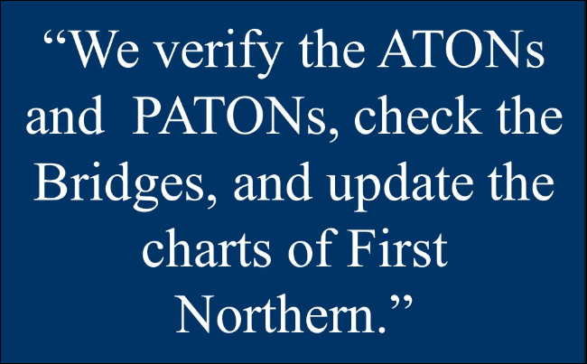

**AV TRAINING 6 –** USING OPEN/CPN CHARTS WHEN VERIFYING A PRIVATE AID AND FOR CHART UPDATING PROJECTS.

**Tuesday, April 10, 2018 @ 2000 to 2200 hrs.**

***Question and Answer Session on Training Session 5 Topics.***

***Presentation Topics:***

* **Using Open/CPN Charts when verifying and checking Private Aids.**

These free on-line charts can easily be maintained in a highly accurate state and offer the AV a series of on-line navigation tools to perform all of the required navigational tasks quickly and accurately.

* **Using Open CPN Charts for Chart Updating projects**.

Special navigational techniques for performing Chart Updating are explained.

**AV TRAINING 7 –** HOW TO DOWNLOAD OPEN/CPN NOAA CHARTS –

HOW TO UPDATE OPEN/CPN CHARTS ON YOUR PC.

**Tuesday, April 24, 2018 @ 2000 to 2200 hrs.**

***Question and Answer Session on Training Session 6 Topics.***

***Presentation Topics***

* **How to download Open/CPN NOAA Charts onto your personal computer.**
* **How to update your Open/CPN NOAA charts on your personal computer.**

***Homework Assignment:***

* Download the First District Open/CPN NOAA Chart package to your PC.
* Read the Federal Regulations concerning Bridges and Bridge Lighting.

AV TRAINING 8 – REVIEW OF BRIDGE LIGHTING AND OTHER SAFETY EQUIPMENT – REPORTING BRIDGE SURVEYS TO THE CG.

**Tuesday, May 8, 2018 @ 2000 to 2200 hrs.**

***Question and Answer Session for resolving download problems on Open/CPN Charts incurred trying to download Open/CPN NOAA Charts to your PC.***

***Presentation Topics***

* **Understanding bridge lighting and safety equipment specifications**.
* **Using the on-line Bridge Reporting System.**

This on-line Bridge System is proprietary to First Northern Coast Guard Auxiliary AVs and is very similar to the on-line bridge system version used by the First Southern Coast Guard Auxiliary AVs. Most other Districts used paper reports that are manually prepared and mailed to the Coast Guard.

***Homework Assignment***

* Log onto the on-line First District Bridge Systems and familiarize yourself with the various screens and their purpose before this training session.

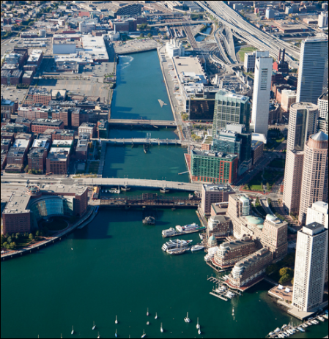

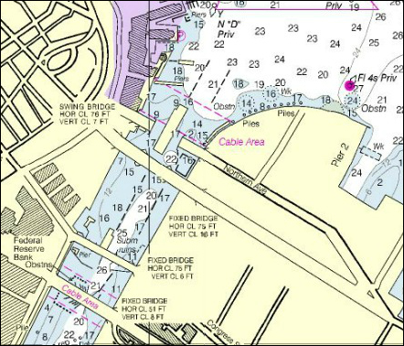

**AV TRAINING 9 – UNDERSTANDING THE PREPARATION OF THE ON-LINE CG-7054 PATON REPORTING SYSTEM ON HARBORMASTER.**

**Tuesday, May 22, 2018 @ 2000 to 2200 hrs.**

This on line PATON management system is only available to AVs in the CG First District

***Question and Answer Session for AV Training 8 – Bridges.***

***Presentation Topics***

* **How to prepare the required CG-7054 PATON Report on-line on the Harbormaster System.**

Since you will not be allowed access to the Harbormaster System until you are AV qualified, this training session is presented on-line and walks you through the various options for creating and submitting a CG7054 PATON Report. You will have to submit on-line 7054 PATON Reports as part of your AV Qualification training.

* **Dealing with lateral aids with critical discrepancies and the need to get the discrepancy reported to the marine public via a LNM – Local Notice to Mariners.**
* **Understanding the PATON Program Screening Process.**

When you submit a CG-7054 PATON Report, it goes into suspension before it is sent to the PATON owner and the CG ANT. This screening process will be demonstrated and explained during this important training session. Note that the screener has the capability to correct your CG-7054 PATON Report in order to maintain the Navigation Systems 100% Report Accuracy Goal. If erroneous or incomplete reports cannot be corrected by the PATON Screener, they will be rejected back to the submitting AV for review and resubmission.

* **District PATON Screener’s Review of the AV’s suspended CG-7054 PATON Report.**

AVs receive back a copy of the CG-7054 PATON Report after it is possibly modified and accepted by the PATON Screener. This important training session demonstrates and explains what report fields are important for the AV to review in order to avoid future report rejections. AVs are asked to think of this report as part of an on-the-job training exercise.

* **The PATON Report Rejection Process and the Review of the AV’s Copy of the PATON Rejection Report.**

When the PATON Screener cannot make appropriate corrections to your CG-7054 PATON Report, the report will be rejected back to the AV. This training session explains what happens when the screener selects this option. A copy of an actual rejection report will be demonstrated and AV follow up procedures will be explained.

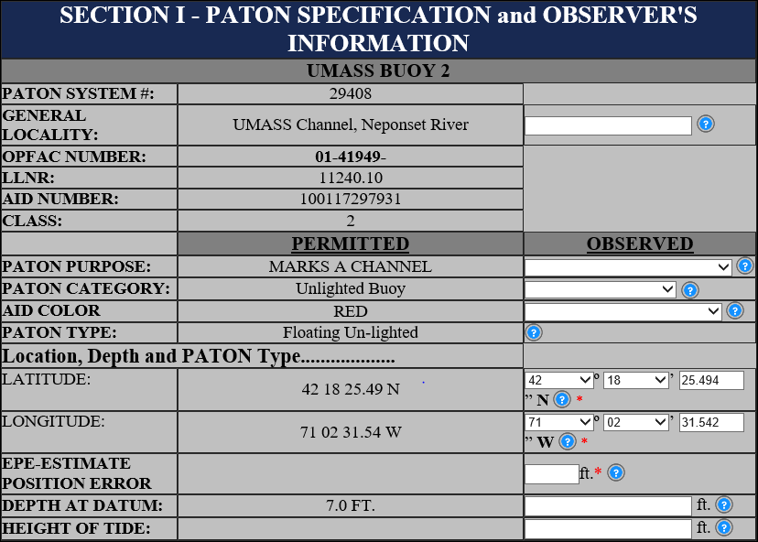

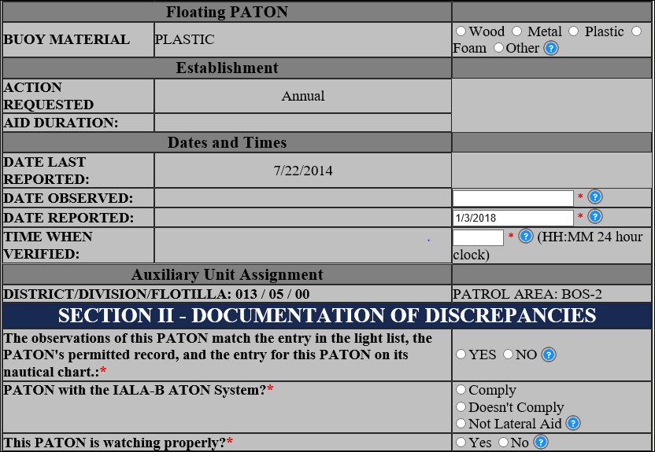

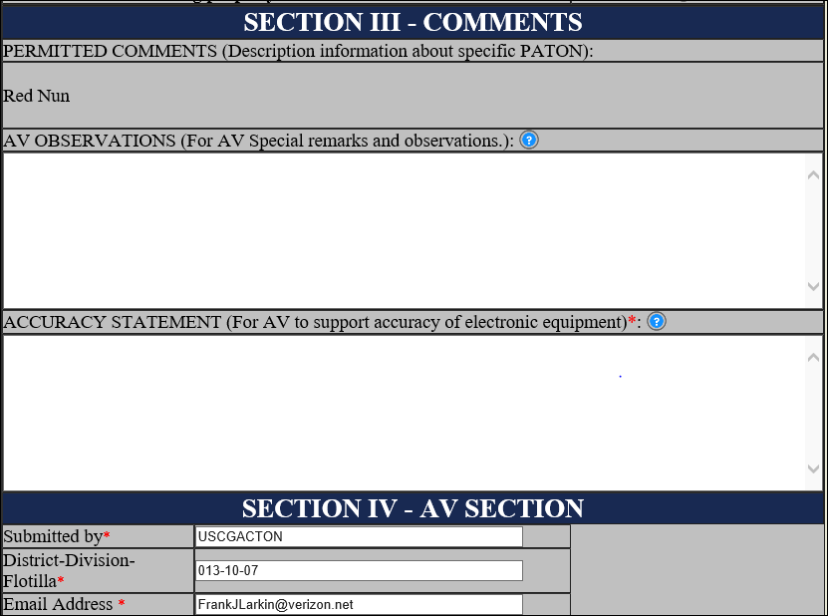

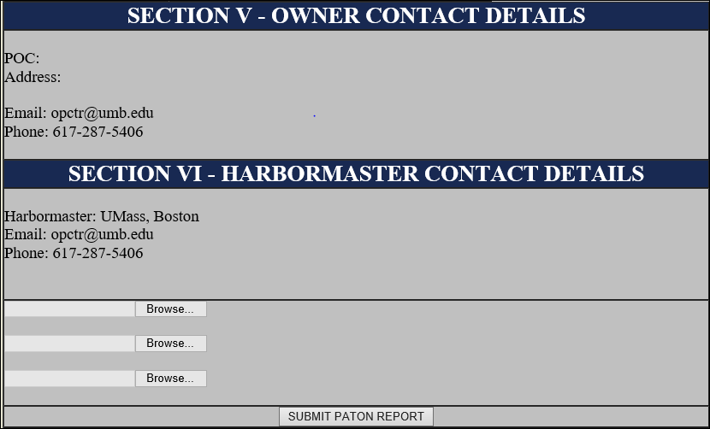

**AV TRAINING 10 – AVC FINAL UNDERWAY CHECK OFF – SIMULATION REVIEW / WALK THROUGH**

**Tuesday, May 29, 2018 @ 2000 to 2200 hrs.**

* AV will pre-underway calibrate their GPS and Echo-sounder that will be used for the PATON Patrol.

This activity is a prerequisite for the preparation of the “***Accuracy Statement***” that is required with each CG-PATON Report that is generated during the PATROL.

* AV will make assignments for the rest of the NS team aboard the vessel. Part of this briefing will be an explanation of the specific private aid verifications and rechecks that are scheduled on the Run Sheet being used for the Patrol. The following assignments will be reviewed:
* **Positioning plan.**
* **Depth plan.**
* **IALA-B Status of the Aid.**
* **Review of discrepancies observed on the private aid.**
* **Quality Control checks on reports.**
* AV will brief the Coxswain as to the directions to the first PATON on the Run and the route that needs to be taken to complete the planned patrol in a complete and timely manner following the sequence of the PATONs on the Run Sheet. Planned route should be presented and reviewed on a current NOAA Chart. Maneuvering and boat speed issues should be clarified with the coxswain at this time.
* AV will direct the verification of a minimum or two laterals aid to navigation and record the required observations on a Run Sheet. Different types of private aids are desired – floating lateral – fixed lateral – regulatory – unauthorized, etc. AV should also perform a recheck of a private aid.

**It is important that an AVC–Aid Verifier Candidate gets underway with qualified AVs before the final “*AV Training 10 Session*” in order to practice the verification and recheck and reporting process. They should schedule rides or plan some simulated events prior to the actual check off.**

**Being able to complete the AV Training Checklist shown at the end of this document will take a bit of practice. The DSO-NS can set up (on-shore) practice events in local areas as needed. AVCs need to take the initiative to arrange for facilities with Internet capability for this purpose.**

**More Important Advice for AVCs!**

**Don’t underestimate the amount of effort that is required to become Aid Verifier Qualified**. Instead, focus your attention on the navigation skills that you will receive from these training sessions. The actual act of verifying a private aid is fairly simple and quick. However, the background knowledge that is required can be burdensome but necessary. A quick method to attain this knowledge is to hang out with qualified and current AVs and participate with them on their Navigation Systems Patrols. ***Don’t be afraid to ask questions***. As your DSO-NS, I have been working with the Aid to Navigation program for over thirty-four years and I still have to ask questions about situations that I run into in the field. We welcome every Auxiliarist to join with us in this worthy Coast Guard endeavor. We also understand that it will take a substantial effort to complete the AV Training. We will work with you to see you through the training and get you qualified. Much of your newly acquired skills will be honed by your activity and experiences in the field. ***This support starts on February 6th on Webex at 8:00pm.***

**Aid Verifier Final Underway Check-Off – AV Training 10**

**AV Candidate ___________________________ Date _______________________**

**Pre-Patrol Activity**

1. AV ordered the correct Run Sheet for the Patrol area prior to the patrol. . . . . . . . . . . . . . . . . . . . . . ___ 2 pts
2. AV pre-reviewed the PATONs on the Run Sheet and was aware of the location of the aids were scheduled for verification, recheck, missing photo and PATON Application. . . . . . . . . . . . . . . . . . . . . .. . . . . . . . ____ 2 pts.
3. AV had the required equipment necessary to complete the required observations.
   1. Marine-grade GPS . . . . . . . . . . . . . . . . . . . . . . . . . . . . .____ 2 pts
   2. Echo-Sounder or Lead Line . . . . . . . . . . . . . . . . . . . . . .____ 2 pts
   3. Camera . . .. . . . . . . . . . . . . . . . . . . . . . . . . . . . . . . . . . . ____ 2 pts
   4. NOAA Chart . . . . . . . . . . . . . . . . . . . . . . . . . . . . . . . . . ____ 2 pts
4. AV made copies of the pertinent documents that support the accuracy of the PATONs info on the Run Sheet being used:
   1. Appropriate pages of the latest *Corrected Light List*. . . . . . . . . . . . . . . . . . _____ 2 pts
   2. Appropriate pages of the latest version updated *Coast Pilot*. . . . . . . . . . . _____ 2 pts
   3. Copies of pages of the latest *LNM* with references to the PATONs on the Run.____ 2 pts
5. AV confirmed that the GPS Set was:
   1. Marine Grade GPS (Had EPE, 3D read out capability) . . . . . . . . . . . . . . . . . _____ 2 pts
   2. GPS was set to read out positions in Degrees, Minutes and Seconds . . . . . _____ 2 pts
   3. GPS was set to Nautical Miles. . . . . . . . . . . . . . . . . . . . . . . . . . . . . . . . . . . . . _____ 2 pts
   4. The AV updated the Accuracy Statement on page 1 of the Run Sheet . . . _____ 2 pts
   5. The position and depth of the Echo Sounder’s transducer was identified . _____ 2 pts
   6. The AV updated the Accuracy Statement with the Mfg. name of the Echo Sounder and depth of the transducer on the Run Sheet . . . . . . . . . . . . .. . . . . . . . . . . . . _____ 2 pts

**Pre-Underway Activity**

1. AV calibrated or checked the calibration of the GPS to insure that it was operating accurately . . . ____ 2 pts
   1. AV updated the Accuracy Statement on page 1 of the Run Sheet . . . . . . . . . . . . . . . ____ 2 pts
2. AV ***Sanity Checked*** that the Echo-sounder was operating accurately. . . . . . . . . . . . . . . . . . . . . . . . _____ 2 pts

A **sanity** test or **sanity check** is a basic test to quickly evaluate whether a measuring device or an aid to navigation meets the specified use for which it is being used. For example, if the AV has pre-plotted the aid on a personal computer using Open/CPN Charts or on their GPS, a quick reference glance will determine whether or not it in ON STA. A quick glance of the object will determine if it meets it physical specs.

It is a simple **check** to see if the produced material is rational (that the material's creator was thinking rationally, applying **sanity**).

1. AV assigned specific tasks to available crewmembers. . . . . . . . . . . . . . . . . . . . . . . . . . . . . . . . . . . . . ____ 2 pts
2. AV Instructed the Coxswain on the recommended route using a current NOAA Chart . . . . . .. . . . . ____ 2 pts

**AV explained the function and assigned specific tasks to available crew members**:

* 1. Aid and discrepancy Photographer. . . . . . . . . . . . . . . . . . . . . . . . . . . . . . . . . . . _____ 2 pts
  2. Observation Recorder . . . . . . . . . . . . . . . . . . . . . . . . . . . . . . . . . . . . . . . . . . . . . _____ 2 pts
  3. GPS Operator and reader . . . . . . . . . . . . . . . . . . . . . . . . . . . . . . . . . . . . . . . . . . _____ 2 pts
  4. Echo Sounder Operator and reader . . . . . . . . . . . . . . .. . . . . . . . . . . . . . . . . . . _____ 2 pts
  5. Timer . . . . . . . . . . . . . . . . . . . . . . . . . . . . . . . . . . . . . . . . . . . . . . . . . . . . . . . . . . . ._____ 2 pts
  6. Aid Observer . . . . . . . . . . . . . . . . . . . . . . . . . . . . . . . . . . . . . . . . . . . . . . . . . . . . . _____ 2 pts
  7. HOT-Height of Tide calculator . . . . . . . . . . . . . . . . . . . . . . . . . . . . . . . . . . . . . . . ._____ 2 pts
  8. Depth at Datum calculation . . . . . . . . . . . . . . . . . . . . . . . . . . . . . . . . . . . . . . . . . _____ 2 pts
  9. EPE-Estimated Position and 3D Error – Reader . . . . . . . .. . . . . . . . . . . . . . . . . . _____ 2 pts

**On Scene Activity**

1. AV indicated three reasons as proof that the correct aid was being observed. . . . . . . . . . ._____ 2 pts
2. **AV supervised the verification of the private aid:**
   * 1. Date and time were recorded on the Run Sheet for the aid. . . . . . . . . . . . . . . . _____ 2 pts
     2. Vessel was maneuvered in position to verify the aid properly and accurately. _____ 2 pts
     3. The position of the aid was observed and recorded in degrees, minutes and seconds - 00-00-00.000 on the Run Sheet. . . . . . . . . . . . . . . . . . . .. . . . . . . . . . . . . . . . . . . .. . . . ____ 2 pts
     4. The EPE-Estimated Position Error and 3D were read and recorded. . . . . .. . . . . ____ 2 pts.
     5. The depth was read and recorded on Run Sheet. . . . . . . . . . . . . . . . . . . . . . . . . . .____ 2 pts
     6. The HOT – Height of Tide was looked up and recorded on the Run Sheet. . . . . . ____ 2 pts
3. Any unresolved, previously reported discrepancies were reviewed and noted on the Run Sheet.___ 2 pts
4. All existing discrepancies observed on the PATON were noted on the Run Sheet . . . . . . .. . . . . . ___ 2 pts

**IMPORTANT**: Whenever an AV observes a critical discrepancy on a lateral aid, the AV must notify the DSO-NS or the CG ANT immediately by phone or e-mail so that the proper LNM-Local Notice to Mariners message can be send to the marine public. Also, the AV must also indicate when and to whom in the CG this message was sent on the CG-7054 Report.

**Report Wrap Up**

1. AV reported a critical discrepancy for a lateral aid to the DSO-NS. . . .. . . . . . . . . . . . . . . . . . . . . ____ 2 pts
2. AV looked up the HOT-Height of Tide for the date/time of the fix and updated the Run Sheet. . ____ 2 pts
3. AV calculated the Depth at Datum manually . . . . . . . . . . . . . . . . . . . . . . . . . . . . . . . . . . . . . . . . . ____ 2 pts
4. **AV calculated the distance between the Permitted Position and the Observed Position in feet:**
   1. Manually using the Open/CPN Chart . . . . . . . . . . . . . . . . . . . . . . . . . . . . . . . . . . . . ____ 2 pts
   2. Using the Run Sheet . . . . . . . . . . . . . . . . . . . . . . . . . . . . . . . . . . . . . . . .. . . . . . . . . . . ____ 2 pts
   3. Using the Navigation Systems Calculator . . . . . . . . . . . . . . . . . . . . . . . . . . . . . . . . . .____ 2 pts
5. **AV made a determination whether the aid was OFF STA (Off Station):**
   1. Manually, using the Off Station Criteria . . . . . . . . . . . . . . . . . . . . . . . . . . . . . . . . . . _____2 pts
   2. Using the Run Sheet . . . . . . . . . . . . . . . . . . . . . . . . . . . . . . . . . . .. . . . . . . . . . . . . . . ._____ 2 pts
   3. Using the Navigation Systems Calculator . . . . . . . . . . . . . . . . . . . . . . . . . . . . . . . . . ._____ 2 pts
6. Using the observed POSN, the AV plotted the aid on the local NOAA Chart . . . . . . . . .. . . . . . _____2 pts
7. AV updated their observations to a computerized Run Sheet . . . . . . . . . . . . . . . . . . . . . . . . . . . _____2 pts
8. Referencing the updated RUN Sheet, AV prepared and submitted a *CG-7054 PATON Report*. _____2 pts



Grading 50 @ 2 Points = 100% (All Tasks)

Logging onto the WebEX Training

1. Go to the Navigation Systems Web Site @ [www.uscgaan.com](http://www.uscgaan.com).
2. Click on the “WEBEX TRAINING” web page from the column at the left.
3. Follow the instructions in the Info Block.

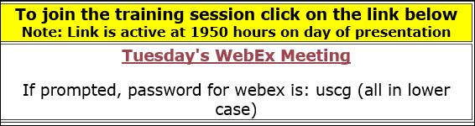

1. When the meeting is started [Check the instruction at the top right for message.], click on “JOIN.”

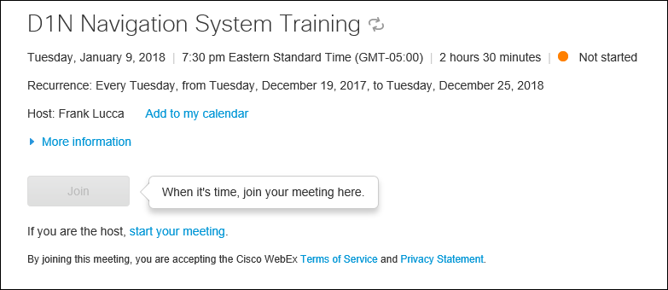

1. You will not be able to join until the Host logs on to the system (Starts the meeting). This will generally be approximately at around 7:30 PM. Note the message at the top right hand side of the above example indicating that the training session is not started.

Revision 1-4-2018

Prepared by the First Northern Navigation Systems Staff. Submit questions to the DSO-NS at [**FrankJLarkin@verizon.net**](mailto:FrankJLarkin@verizon.net) or ADSO-NS Michael Quinn at [**MichaelSQuinn@gmail.com**](mailto:MichaelSQuinn@gmail.com)

