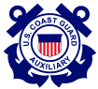 | United States Coast Guard Auxiliary  PREVENTION (Marine Safety) DEPARTMENT  NAVIGATION SYSTEMS DIVISION
Taking and Reporting Fixes and Depths to Government Agencies

In appreciation for the Navigation Systems Division’s goals of accuracy, credibility, professionalism and service to the Coast Guard, it is necessary to revisit the ways that, as Auxiliarists, we submit information to all branches of the Coast Guard and other agencies such as NOAA. So much information, in the past, was unusable that a negative image of the Auxiliary was created. Adhere to the following suggestions and you can be assured that your data will be of high quality.
First of all, it is important that both the provider and user fully understand the ability of the Coast Guard Auxiliary to develop data versus data generated by Coast Guard personnel. Note that the Auxiliary doesn’t “position,” we “locate” items using GPS fixes. The term “position” should not be used in your reports. There is a significant difference between these two terms. While the Coast Guard uses computers to calculate “positions,” the Auxiliary uses a GPS to generate “fixes.”
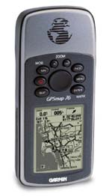 | That doesn’t mean that the Auxiliary’s data is not useful. But, it does mean that Auxiliary-provided data cannot be used for some official Coast Guard positioning records. In order to become a credible resource, always provide evidence of the quality level attained you achieved while generating the data. This involves pre-calibrating the electronic equipment being used to show that it is working properly, reporting on-scene quality information as to the accuracy that the equipment attained when readings are taken and reporting the model and manufacturer of the equipment used. All of these informational elements create an aura of credibility to your report. And, while it looks like a major information gathering exercise, all of this information is readily available on your GPS. Below are some guidelines.
Pre-underway checks of electronic measuring equipment are necessary.

Aid to Navigation and Chart Updating activity require a very precise use of navigation measuring equipment. Unfortunately, you may find that some of the equipment found on an OPFAC does not meet the accuracy and quality standards needed for taking proper on-scene fixes and depths required for formal reports to the Coast Guard and NOAA. Never embarrass yourself by submitting low quality data, or by not being able to make proper measurements due to equipment breakdowns or failure. Always be prepared. The two major problematic items will be GPS sets and echo sounders.
A handheld GPS that is equipped with WAAS is a great adjunct to your navigation kit. Verify that the GPS is operating accurately during the pre-underway check by verifying its read outs against the OPFAC’s GPS or against a known charted location. Explain how your GPS was calibrated during your pre-underway check in your reports. Mount the hand-held GPS to a large clipboard to keep it safe and available throughout the patrol. Purchase a power cord for your handheld GPS that plugs into the OPFAC’s 12V receptacle to save your GPS set’s batteries. This also allows a continuous lighted screen during night operations. Keep the power cord in your personal Navigation Kit along with spare batteries.
As part of a pre-underway check, verify that the OPFAC’s GPS is set up correctly. Here are a few key items can have a serious effect on the accuracy of your final reports.
- Horizontal Datum – (Area) Does it match the horizontal datum on the NOAA nautical chart that you are using? If not, correct the horizontal datum in the GPS set to match the nautical chart. New GPS sets usually come preset to WGS84 and most NOAA charts have WGS84 datum references. However, don’t assume. Only charts with WGS84 or NAD83 Datum can be used.
- Vertical Datum – (Depth) Does the unit of measure on the echo sounder match the depth showing in the General Information Block on the nautical chart that you are using? When they do not match, update the depth unit of measure on your echo sounder to match the chart before you get underway.
- Operational accuracy – Confirm that DGPS and/or WAAS is activated on the GPS set. Verify the EPE or HDOP readings during the pre-underway check to insure the GPS is performing at a high quality level. The GPS set should be operating in 3D or 3D Differential when reading are taken.
- Nautical miles vs. statute miles – New GPS sets usually come set to statute miles. Ensure that the GPS set that you use is reading in nautical miles. A quick glance of a screen can tell the tale. If it is showing “MPH” not “kts” or” nm,” it needs to be reset.
- GPS headings and bearings – Be sure that the read out on your GPS set and your compass match--True or Magnetic. Be sure that you understand how your electronic equipment is reading before you use it to gather data. If magnetic, you will need a copy of the OPFAC’s Deviation Table.
Nav Gear | Are the NOAA Charts of AOR on board?
Nav Gear | Is the Navigation Kit on board?
Nav Gear | Are the Binoculars on board?
Nav Gear | Was the compass pre-calibrated?  Read out is (True or Magnetic)?  Is a Deviation Table available?
Nav Gear | Is a RPM Table available on board?
Nav Gear | Is there a Timepiece on board?
Nav Gear | How was Echo Sounder pre-calibrated?  Correction for transducer location:
Nav Gear | Does the Vert. Datum match the chart?
Nav Gear | Is there a Light List on board?
Nav Gear | Is there a Coast Pilot on board?
Nav Gear | Is there a Tide Tables on board? (Available on a GPS)
Nav Gear | Is the Nav Rules on board?
Nav Gear | Forms, pencils, and paper on board?
GPS | How was the GPS calibrated?
GPS | Is the Hor. Datum the same as chart?
GPS | Does GPS Distance = Nautical Miles?
GPS | Heading (True or Magnetic)?
GPS | Vertical Datum (Feet, Fathoms)?
- Latitude and Longitude - Set the Latitude / Longitude in the GPS to degrees, minutes, and seconds. This is the standard format for reporting to the Coast Guard and reflects the LAT/LON used in the Light List. This adjustment is performed on the Set Up screen and only takes a minute.
- Check that the compass is operating correctly –If your boat is moored to a finger float, check the reading that should be constant. Otherwise, use a known range. Compare the compass reading to the bearing being produced by your GPS. If the difference approximates the local Variation, you need to adjust your GPS.
- Is the Patrol’s planned route is loaded into the GPS? Operating on a pre-planned route not only saves you fuel and time, it is one of the best safety precautions you can establish to ensure you will be able to navigate back home if the weather deteriorates suddenly of you have to return to your home port at night. It much easier and safer to navigate on a pre-checked route that to bob around trying to pick up an aid to navigation in the dark or fog. Another possibility is too clear the track line in your GPS before you get underway, so you can return on the set’s track line if weather deteriorates. Caution: Be sure that you are operating at a slow speed and that the GPS approach or proximity alarm is set. It is very easy to hit an aid to navigation in the darkness.
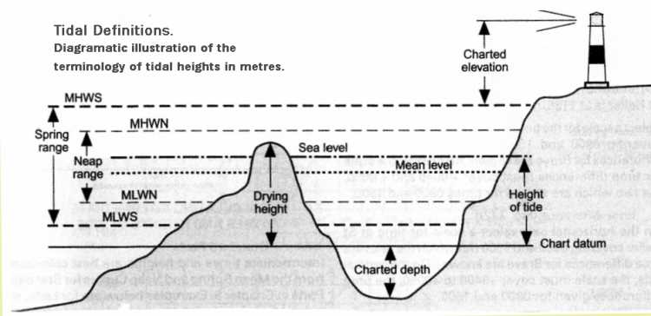

- Pre-calibrate the echo sounder. This can be accomplished with a lead line or a sounding pole. Or, you can simply correct your echo sounder’s reading to the charted datum at your dock. The answer should always be approximately the same. The observed depth is 9.4 ft. The correction for your transducer is 0.8ft. and, the height of tide is 5.2 ft. [9.4 ft plus 0.8 ft minus 5.2 ft. equals 5.0ft. Compensate for the location of the transducer on your OPFAC by adding it to the observed depth Correct for tidal influence by subtracting the height of tide..
- Check that the OPFACs nautical chart is current and updated to the latest LNM. To be safe, carry the latest nautical charts in your navigation kit.

Guidelines for Taking a Fix
A GPS set using WAAS, or a DGPS set, is the recommended tool for taking a fix. Hand held GPS sets with WAAS can produce LAT/LON (Fixes) within 8 to 12 feet of the actual position of the aid on the earth’s surface. That is inside the head of a pinhole on the chart. Horizontal sextant angles and bearings using a hand-held compass are not considered sufficiently accurate for use in the Auxiliary ATON program for taking a fix.
- Perform a Pre-underway Check on the GPS being used.
  - Report how the pre-underway check was performed.
  - Record the Manufacturer Name and Model Number on your report.
  - Indicate how you know that this instrument was operating accurately
  - Show how accurate the instrument was by reporting the EPE or HDOP readings achieved during the pre-underway check.
  - All of this data is available from your GPS and GPS Operating Manual.
- Explain how the fix alongside the object or aid was determined and calculated.
  - Fixes taken to static objects – fixed aids or charted objects.
    - Move the GPS as close as possible to the fixed point or target.
  - Fixes taken of floating objects – floating aids or docks.
    - Read the Fix after the vessel stops alongside the floating object. Recording fixes while an OPFAC in motion introduces excess error to the GPS and will produce inaccurate readings.
    - Record your LAT/LON observations on a worksheet. Write clearly. You won’t remember crossover and overwritten corrections later on when you are preparing your final report.
  - Make a note of exactly how the fix was obtained.
- Record quality control support for the fix, such as EPE and HDOP readings. Also show date and time. This practice significantly improves the quality of your reports.
- Double check your readings before leaving the scene.
  - It is an efficient practice to use two GPS sets to double check your readings.
Guideline for taking and reporting a Depth
Random reporting of depth readings from echo sounders produces useless data. Besides the need to control the quality of the measuring instrument, from a practical aspect, depths must relate to the depths recorded on the nautical chart. Otherwise, depths reported in areas affected by dams or tidal action are always vacillating. This difference becomes more significant in areas in the higher latitudes where tidal ranges vary from 10 to 12 feet. Depths taken in stormy weather where the wind has a long fetch will not be accurate.
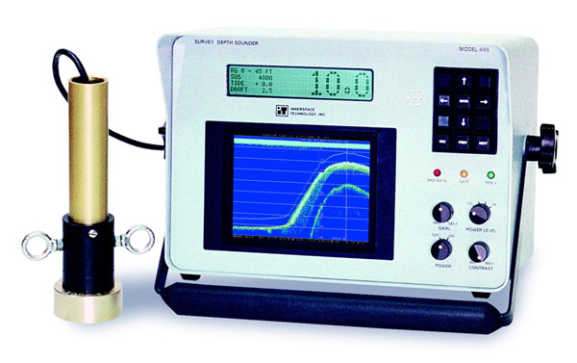
- Perform the pre-underway check of an Echo Sounder.
  - Check that the vertical datum (feet, meters, fathoms) shown in the General Information Block on your nautical chart reflects the depth datum reading on your echo sounder.
  - If your echo sounder is integrated to your GPS set, verify that the depth datum (unit of measure) on the nautical chart, on the echo sounder and on the GPS set match.
  - Make note of the distance from the waterline to the location of the echo sounder’s transducer beneath the water so you can correct your depth readings.
  - Use a lead-line or a sounding pole to validate the echo sounder’s depth reading while still at the dock or mooring.
    - Compare the echo sounder reading plus the correction for the transducer to the depth obtained with the lead-line or sounding-pole.
  - Carry a lead-line in your navigation kit as a backup to your echo sounder.
  - On your report, list the manufacturer’s name and model number of the echo sounder that is used.
- Maneuver your vessel as close as possible to the object or aid without leaving the navigable channel.
  - Be alert for riprap, shoaling, or other obstructions near the object or aid. If you think there may be a problem, abort the attempt. Safety first.
    - Try to observe the object or aid at low water from a safe distance to check for the suspected obstructions.
    - Return at high water to take the depth reading.
- Record and report the date and time for each depth that you take.
- If you are operating in a tidal area, also record the “height of tide” for the time when the depth was taken.
  - Record the “height of tide” from the Almanac Screen on your GPS.
  - Be sure that you are referencing the nearest Substation on your Almanac Screen.
    - Substations are geographically sensitive. As you move around in an AOR, they can change.
    - Substations are usually presented on a drop-down menu on the Almanac Screen on your GPS. Most sets have an option for selecting, “Nearest Substation.” Further enhance your credibility by reporting the substation used on your report.
  - Calculate the “Estimated Depth at Charted Datum” for your report, as follows:
    - Observed Depth (from the echo sounder) plus the correction for the location of the vessel’s transducer minus the “Height of Tide” equals the “Estimated Depth at Charted Datum.”
    - This is called an estimate because the height of tide is a projected figure not the actual height of tide. If necessary, your depth can be corrected by the receiving agency using the date and time information provided on your report.
  - Compare the “Estimated Depth at Charted Datum” to the depth appearing on the nautical chart.
    - A large depth discrepancy may be an indication that the object or aid is not on its permitted station. In this case, you will need to take multiple readings as evidence to prove your case. More important is whether the aid is marking best water.
    - Comment on this comparison in your report.
- Quality Statement for PATON Reports
- Many AVs are using the statement below in the Comments section of their PATON Reports as a statement of the quality of their submission. Much of the data is static, reflecting the pre-underway check status--the model and manufacturer’s name. The rest of the data is collected on scene.
“Location was checked by a [GPS Model No.] by [GPS Manufacturer] with [WAAS or DGPS] enabled and was pre-calibrated with a [Indicate method]. GPS was operating in [3D or 3D Differential]. [EPE or HDOP] was ___ft. Echo sounder was a [Model Number and Manufacturer’s Name] that was checked for accuracy at the dock with [Indicate method used]. Depths are adjusted to charted DATUM using a ___ ft. correction for the location of the transducer on the vessel and for an estimated height of tide from the GPS of ___ft. Depth was taken at _____.”

- Many AVs are using the above statement in the Comments section of their PATON Reports as a statement of the quality of their submission. The yellow data is static, reflecting the pre-underway check status--the model and manufacturer’s name. The green data is collected on scene. Keep this statement in your computer and simply copy and paste it on each report and update the necessary fields.
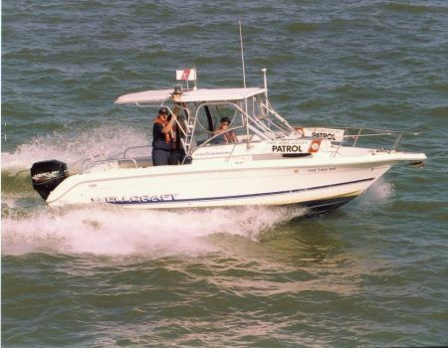 | If you are not following these guidelines, you may not be doing a complete and accurate job of reporting fixes and depths to the Coast Guard or NOAA.
Print some copies of this flyer and hand them out at your next Flotilla and Division meeting.

If you want to learn more about the ATON, PATON, Bridge, Chart Updating and Small Craft Facility Programs, contact your AN Staff Officer for more information. These are great introductory programs for new members. We will train you.

Prepared by:
Frank Larkin, DSO-AN 013
978-263-3023
FrankJLarkin@verizon.net

