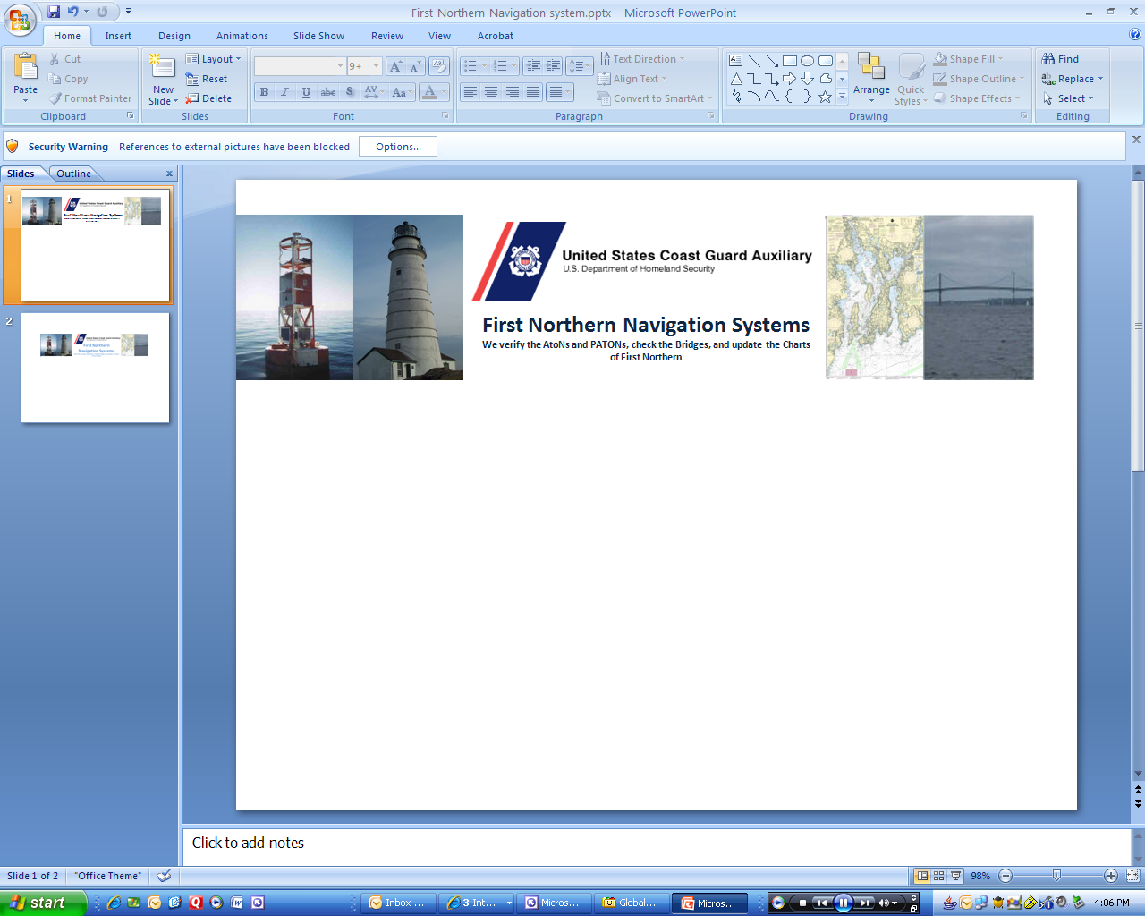

**NS-PN11 REPORTING YOUR NAVIGATION SYSTEM ACTIVITY TO AUXDATA**

Many AVs have problems reporting their Navigation System (NS) activity to AUXDATA. NS programs are focused on Federal Aids (ATONs), Private Aids (PATONs), Bridges and Chart Updating. The evidence for this statement is that many AVs are not submitting *7030 AUXDATA Activity Reports* to AUXDATA for their NS activities. This guide explains some easy steps to help you submit your Navigation System activity quickly and correctly whether the activity is performed underway on CG AUX orders or while on your personal time.

Navigation Systems is authorized to participate in four different Coast Guard and NOAA programs. Under this authorization, all Auxiliarists are encouraged to report all observed **PATONs, ATONs** and **Bridges** discrepancies to the Coast Guard, and to observe and submit **Chart Update Reports and Coast Pilot updates to NOAA.** However, only Auxiliarists, who are Aid Verifier (**AV/PQS**) qualified and current, may perform PATON verifications and annual Bridge surveys.

There are three important aspects that are part of every Navigation Systems activity.

**First** is the actual observation that the AV performs and reports to the Coast Guard or NOAA.

**Second** is the time spent underway on an official patrol that is accounted for by the **AMOS** report that is submitted to AUXDATA by the Coxswain or Owner of the facility?

**Third** are the number(s) of ATONs, PATONs and/or Bridges that were checked, verified, re-verified or surveyed during the patrol.

**IMPORTANT** – Participating NS activity must be divided up to each AV on the patrol but be submitted by each individual AV using a *7030 AUXDATA Activity Report – Individual* to *AUXDATA* through their IS Staff Officer.

AVs reporting NS activity into AUXDATA is critical for maintaining each AV’s currency and qualification. Statistics developed from this data are extremely important for the future recognition and funding of our Navigation Systems activity by the Coast Guard and for awards and commendations by the Auxiliary.

How the ANSC 7030 Activity Report-Individual is completed and submitted to AUXDATA is explained along with the three mission codes in the following sections:

1. **Reporting** **Federal Aids -** **ATON activity using the Mission Code 30** on a **7030 AUXDATA Activity Report**. **Page 2**
2. **Reporting Private Aids - PATON activity using the Mission Code 31 on a 7030 AUXDATA Activity Report****.** **Page 3**

1. **Reporting BRIDGE activity using the Mission Code 32 on a 7030 AUXDATA Activity Report****.**

You may also use the *7030 AUXDATA Activity Report* found on the on-line Bridge System Report. **Page 4**

1. **Reporting Chart and Coast Pilot Updates** **using the** **Mission Code 41 on a 7030 AUXDATA Activity Report**. **Page 5**
2. **How your underway time on a Patrol is reported and handled by AUXDATA****. Page 6**

1. **How your individual activity is reported and handled by AUXDATA****. Page 6**
2. **Reporting ATON activity while on your own time. Page 9**
3. **Capturing all other ATON and NOAA activity on the 7029 form****. Page 9**

**1.** **MISSION 30 – FEDERAL AIDS TO NAVIGATION (ATONs)**

* Activity performed by anyAuxiliarist reporting casually observed discrepancies on a Federal Aid to Navigation (ATON) should include the hours expended on their 7030 AUXDATA Activity Report.
* Only submit discrepancy reports for Federal Aids to the Coast Guard ANT that manages the Aids in that location.
* **“Casual reporting”** is defined as any reporting that is performed from the land or when the Auxiliarist is not under formal orders on an Auxiliary facility or private boat.
* ***Activity credit*** is authorized for any casually reported ATON discrepancy reports using a *7030 AUXDATA Activity Report – Individual* by any Auxiliarist or AV.
* ***Activity credit*** is allowed in **AUXDATA** for all Federal aids observed on an authorized patrol by a qualified and current AV as watching properly or as discrepant since this activity is required as part of the Navigation System annual work schedule.

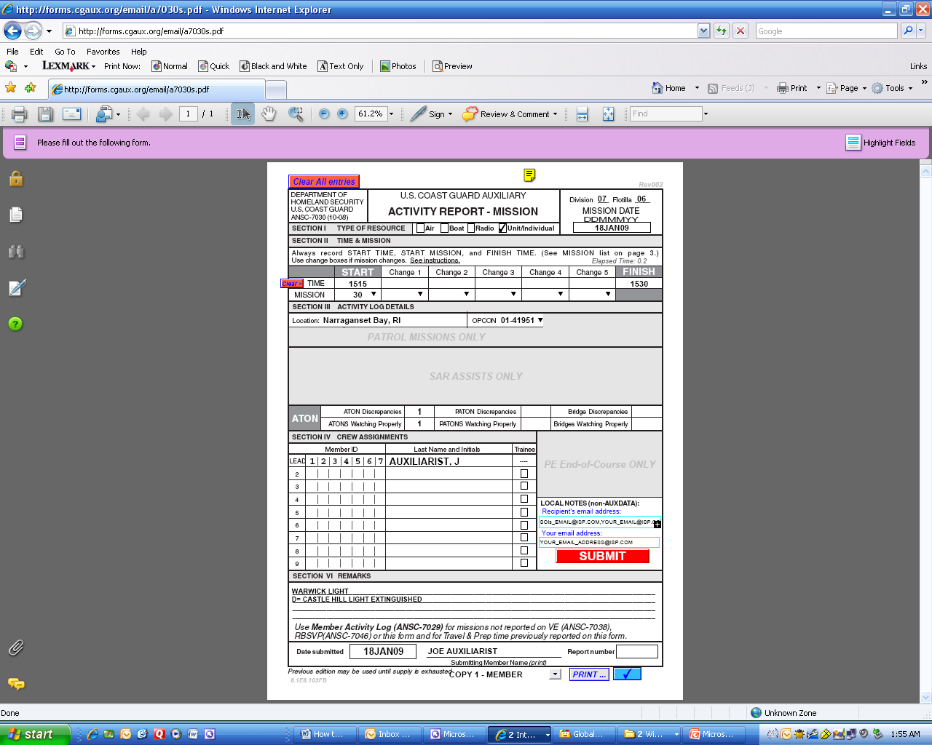

**EXAMPLE**

This **7030 AUXDATA Activity Report – Individual Report** shows two Federal ATONs being reported to AUXDATA. The activity was authorized by the CG ANT request. Two lights that were thought to be emitting the wrong light characteristic were checked. One **ATON** was watching properly and one was discrepant.

This activity was performed as part of an authorized patrol so only 15 minutes of time **was** recorded to satisfy AUXDATA. The AVs actual time underway was submitted by the Coxswain as part of the required ***AOM*** report.

**Note:** Actual Federal ATON Discrepancy Reports are forwarded to the Coast Guard ANT that manages the ATON by the Auxiliarist or AV who made the discrepancy observation about the Federal Aid. PATON and Bridge reports are made with on-line systems.

It is best to Email your report to the CG ANT POC or Chief with a copy to the DSO-NS.

* This Mission Code 30 also includes hours spent by a Certified Aid Technician “MTCN” servicing any Federal Short Range ATON (including Lighthouses).

**2. MISSION 31 – PRIVATE AIDS TO NAVIGATION (PATON)**

* ***Authorized activity*** includes hours expended and the activity performed by ***any Auxiliarist casually reporting*** discrepancies observed on a private aid to navigation (PATON).

1. ***Only discrepancy reports for private aids are submitted to the Coast Guard***. Activity credit is only authorized in AUXDATA for these discrepancy reports on a ***7030 AUXDATA Activity Report – Individual*** transmitted to their IS Staff Officer.

* Activity credit ***for all formal PATON verifications and checks***, performed by a currently certified and qualified **AV-Aid Verifier** at the direct request of any CG Unit or as part of the Navigation Systems annual PATON schedule or for unscheduled PATONs observed as discrepant, are authorized in AUXDATA.

1. Each AV should submit their own ***on-line 7054 PATON Verifications Reports*** to the Coast Guard using the on line PATON (Harbormaster) HM System and their own ***7030 AUXDATA Activity Reports*** to AUXDATA through their IS Staff Officer.

* **REMEMBER:** Don’t report the same hours on your 7030 Report that were reported to AMOS for the Patrol.
* Do not confuse this requirement with all the *CG-7054 PATON Verification Reports* that the AV must submit on-line to the Coast Guard via the PATON (Harbormaster) System.
* Activity credit is authorized in AUXDATA for all PATONs that are verified by an AV as part of the Annual PATON Program schedule. AVs may also include hours and activity for documenting and reporting Unauthorized Aids to Navigation.
* Unauthorized PATON reports activity may be reported as *discrepancies* in AUXDATA

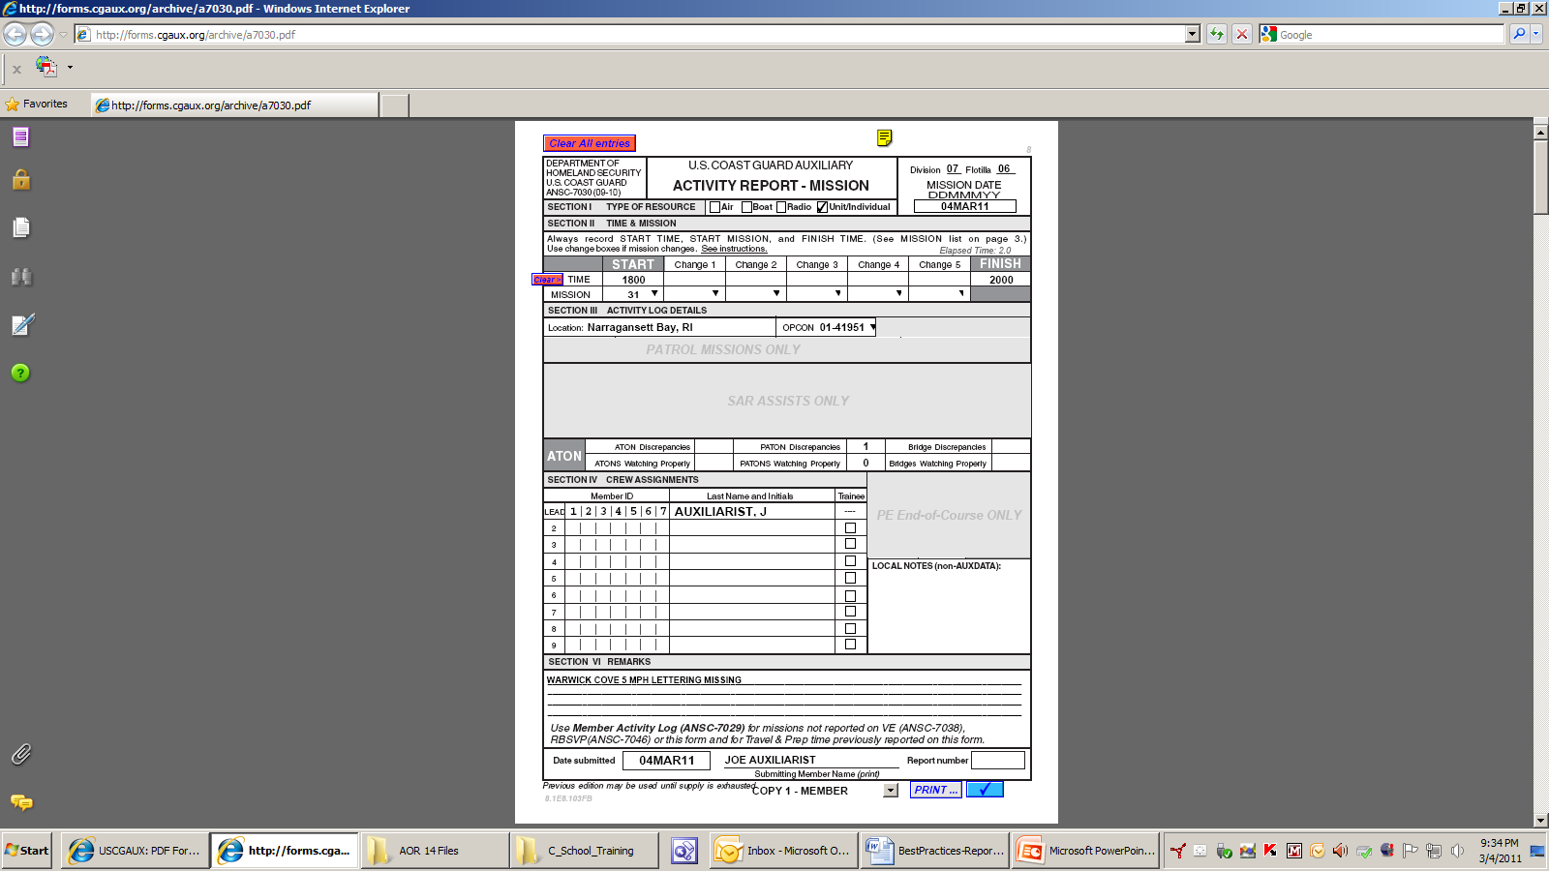

This **7030 AUXDATA Activity Report – Individual Report** example shows one discrepant PATON being reported to AUXDATA. A lighted regulatory buoy was observed with a missing letter while on a recreational trip. It was also reported to the CG ANT on an on-line C-7054 PATON Verification Report by the observing AV. Two hours were taken for observing and reporting the aid, [1800 to 2000 hrs.]

NOTE: copies of the CG-7054 PATON Report are transmitted to the CG ANT and the PATON Owner.

**3. MISSION 32 - BRIDGES**

* **Bridge Survey** activity includes the hours expended and the activity performed by any Auxiliarist reporting any bridge lighting and fender system discrepancies.
* All Bridge Discrepancy Reports **should be** submitted on-line using the ***First Northern Bridge System*** available at ***www.uscgaan.com***. This on-line reporting is the quickest route for getting your report to the CG Bridge Branch in New York.
* Activity credit and hours spent by a currently certified and qualified **AV-Aid Verifier,** while surveying bridge lighting and fender systems at the direction of a Coast Guard Bridge Administration or as part of the Navigation Systems annual Bridge Program schedule,are authorized in AUXDATA.
* ***Each AV should submit their own on-line Bridge reports*** using the on-line First Northern Bridge System and their own 7030 AUXDATA Activity Reports to AUXDATA through their IS Staff Officer. Report multiple bridge activity on a single 7030 Activity report - Individual.
* ***Activity credit*** for all formal ATON Bridge Surveys, performed by a currently certified and qualified **AV-Aid Verifier** at the direct request of any CG Unit or as part of the Navigation Systems annual Bridge schedule survey activity, is authorized in AUXDATA.
* All **formal** Bridge Survey reports are required to be submitted to the Coast Guard using the on-line First Northern Bridge Reporting System.

1. The Bridge Branch in New York is immediately notified on-line by the First Northern Bridge Reporting System after your Bridge Report is screened and accepted by the DSO-NS. The DSO-NS is alerted by e-mail when you submit your Bridge Report.

**Using the 7030 AUXDATA Activity Report provided on the Bridge System**

* AVs may choose to use the **7030 AUXDATA Activity Report** provided on the on-lineBridge System. Access is available by clicking on the **SUBMIT 7030** bullet found at the top left of your Division Screen. Note the **red arrow** on the illustration shown below.

**Note that AVs must elect to use this option. It does not happen automatically as part of the on-line D1NR Bridge Discrepancy and Annual Reporting System.**

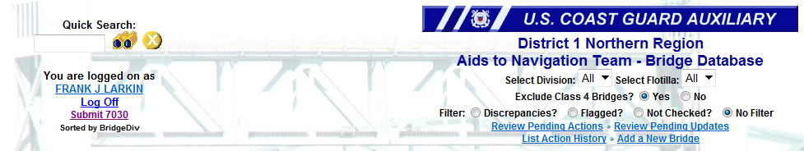

**Click here to activate the 7030 report**

* The Bridge System pre-enters your personal information from your Auxiliary record and opens up additional 7030 fields to use for completing the 7030 report.
* Only ***Mission 32 Bridges*** can be reported using this option. Entering data in the additional fields is explained below. The system pre-enters much of the required data for you.

.

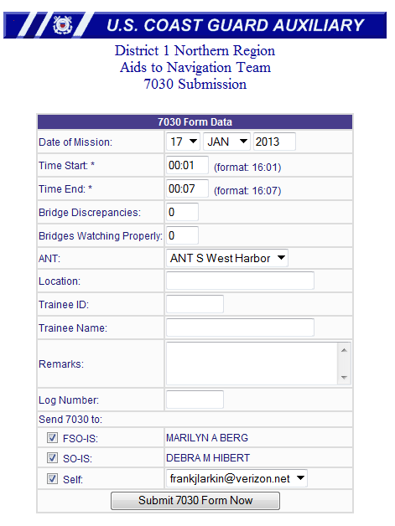

**Follow these simple steps:**

1. **Date of Mission** - The system enters the current date. Use the drop down menus to make any date changes.
2. **Start and End Times -** If the activity was performed as part of an authorized patrol, do not change the Start and End Times. Otherwise, enter the full time that you expended.
3. **Bridge Discrepancies -** Enter only the total number of Bridges that you observed as Discrepant and/or Watching Properly.
4. **Bridge Watching Properly -** Enter the total number of Bridges that you observed as Watching Properly.
5. **OPCON**- The system updates this field from your IS Record in AUXDATA.
6. **Location** - Enter the Location where you performed the reported activity.
7. **Trainee ID** - If a Trainee is involved, enter their ID Number.
8. **Trainee Name** - If a Trainee is involved, enter their name.
9. **Remarks and Log Number**- As an option, you may enter any Remarks and assign a Log Number. This data is not retained in the AUXDATA entry.
10. **Send to IS Officer** – Click on the appropriate IS Office FSO-IS or SO-IS. The system looks up and adds in the IS Staff Officer of record to the reports field(s). Also check off “Self” so that you get a copy for your records.
11. Click in the submit button to transmit your report to the selected IS Officer(s).
12. **Reporting Chart and Coast Pilot Updates** **using the** **Mission Code 41** **Federal Suppor**t **on a** **7030 AUXDATA Activity Report**.

* This activity includes hours spent providing operational/non-operational support to other federal agencies, such as Customs, Corps of Engineers or NOAA as requested and authorized by the Coast Guard. Authorized under this mission code are *Chart Updating and Coast Pilot correcting* *and updating****.***

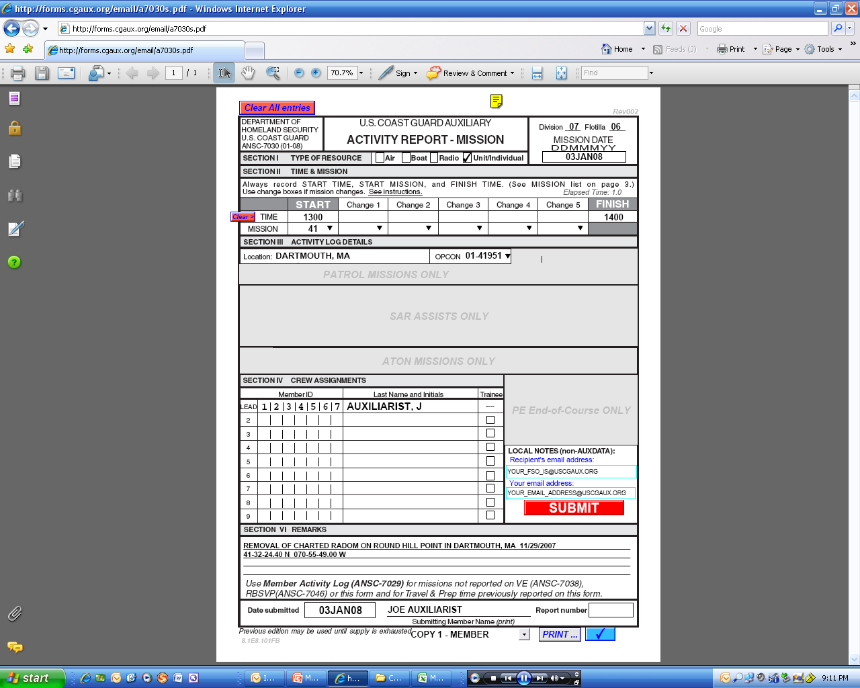

This *7030 AUXDATA Activity Report – Individual Report* example shows time being reported to AUXDATA for a Chart Updating exercise. A charted Radom was reported as being destroyed and removed. One hour is reported for doing the research and completing the CU Report to NOAA and to AUXDATA.

1. **How your underway time on a Patrol is reported and handled by AUXDATA****.**

**VERY IMPORTANT: The AOM System has no capability for accepting or reporting any ATON, PATON or Bridge AUXDATA activity data or actual observations of ATONs, PATONs or BRIDGES.** **It only handles your time underway for the patrol.**

All authorized patrol mission time underway is handled and entered by the Coxswain within the online Resource: Boat or AOM 7030 form, on which all members on the patrol receive credit for the time underway regardless of the boat mission(s) (01, 02, 03, etc.). The Coxswain is the only crew member authorized to submit an *ANSC 7030 Activity Report Mission - Boat* for a patrol.

As was explained in a previous section, each individual Auxiliarist must submit their own 7030 Activity Report, Individual in order to get their NS activity recorded in AUXDATA.

1. **How the NS Individual activity is reported and handled in AUXDATA**

* Once a patrol ends, each participating AV is responsible for filling out their own ***7030 AUXDATA Activity Report – Individual*** to report their assigned portion of the number of ATONs, PATONs and/or Bridge mission(s) that were just completed while underway.

|  |
| --- |
| **Note:** Members without AV qualification cannot report Navigation Systems PATON verifications, scheduled PATON re-verifications and annual Bridge survey activity. This NS activity is restricted to Auxiliarists who are currently certified and qualified as an AV-Aid Verifier. Only current and qualified AVs are allowed access to the Harbormaster System**.** |

* The ***7030 AUXDATA Activity Report, Individual*** form can be used to report all ATON, PATON and Bridge Activity to AUXDATA. Optional 7030 AUXDATA Activity reports can be selected on the First Northern Bridge System to save you time. The 7030 AUXDATA Activity Report – Mission form is explained below:
* **To prepare a 7030 Activity Report – Mission, follow these steps**:

1. A practical example of this report is shown on the next page.
2. Whenever possible, use the national email forms as they will only allow you to fill out the specific section relevant to the mission that you’ve selected. If you’d like to give it a try, access to this form is provided on the ***D1NR Navigation Systems Web Site*** at [**www.uscgaan.com**](http://www.uscgaan.com).
3. **IMPORTANT:** For NS activity performed while on an authorized patrol, the “start time” must be any time BEFORE or AFTER the time reported on AMOS for the patrol.

* The reason for this is that AUXDATA cannot handle you being reported in two places during the same time period. ***Overlapping mission times reject in AUXDATA.***
* For example, if your Mission 01a - Safety Patrol ended at 1500 hours, start your 7030 AUXDATA Activity Report time at 1515 and terminate it at 1530. The total time that you can report for activity should be the lesser of 15 minutes. This doesn’t mean that you took only 15 minutes to perform the NS activity. AUXDATA requires some interval of time associated with each mission, so regardless of the number aids, bridges etc. you checked, you should only take 15 minutes **or less** because the “Boat” report, submitted by the coxswain on AOM**,** credits you for your actual time underway. Otherwise, you would be reporting your time twice. **A simple solution is to always enter 00:01 as your start time and 00:07 as your end time.**

1. **NOTE** that you can report the time that you spend before and after the patrol preparing the *CG-7054 and AUXDATA 7030 reports* that you have used and submitted for the patrol.

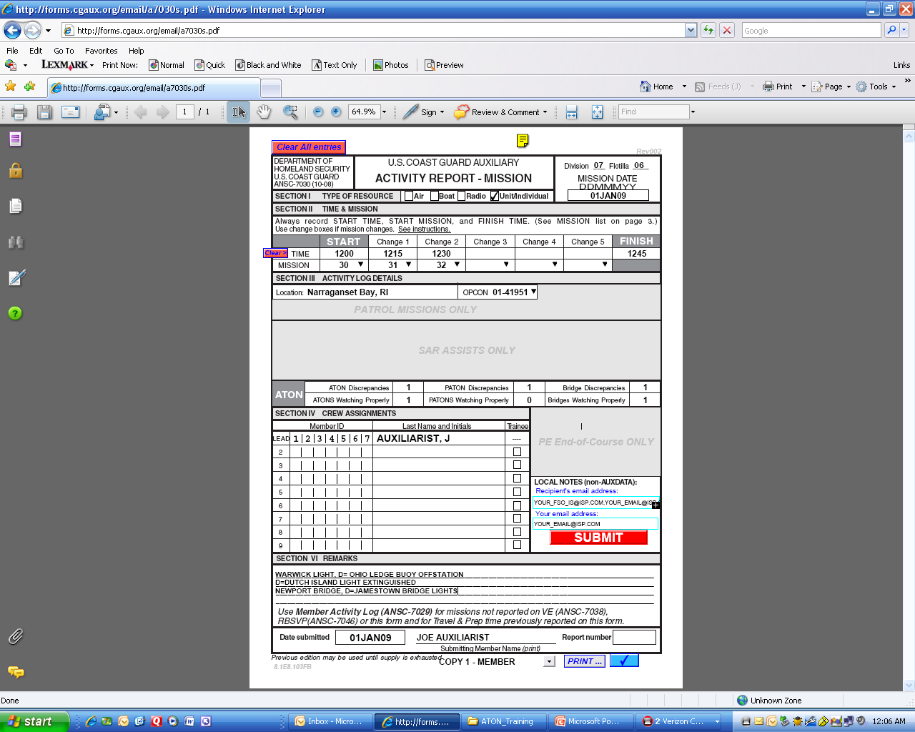

When reporting your mission activity, be sure to fill your activity in the proper ATON, PATON or Bridge sections on the *AUXDATA 7030 Report.*

Report multiple missions and in the same order as the activity fields are listed – Mission 30 – ATON, Mission 31 – PATON and Mission 32 – Bridges. View the example to the left.

For another example: If you select Mission 30, because you are reporting Federal aid activity, only enter your actually observed number(s) or allotted numbers in the “ATON Discrepancies” and “ATONS Watching Properly” fields provided below.

1. Likewise, when you are reporting Bridge - Mission 32 activity, only use the activity fields specifying “Bridge Discrepancies” and “Bridges Watching Properly.”

Please check AUXINFO occasionally to verify that what you have reported is being entered correctly. See the example below. To see your NS activity [Click here for NS AUXINFO 2011 report](https://www.auxinfo.uscg.gov/cognos/cgi-bin/ppdscgi.exe?BZ=1AAADEf2V7mQABEwU6VFChpEgVbAQCUIlaCswmpRpI6aM3EdBxtBJYydtX5k5JoRE6VEGBgwSMftgxGyDBAmSfTW76~lv7rVhFq78SARhw~YGVdw2Z04JGDn11iTNnDlp3rhNgyZFgkypIqXIVNorS5kwctPYceHsmgGzr0zMPrGykkmsZhIrml7l1BxiEjnI1HXlSD3KFvuiWJEChUqaIHSSFDECRwuSJmesHMFxhkobIzLCXCGDhswRNnbENuxNEz1B5vYV~ZEE7lkMhWRWTiGZdWwA84eVKzXg1pOVNUmMOIGRBYsUNmPyCCEiRoYRPWSGCEFC5oqRPFqOlJhBNkt1MHSycAqpLOOimeEkNUHwNKH6g0gRuvoqknf7E56Gs4hTmIuQIEFE5psxMnDcKCFjrFDy1IPkTV1TbwNu3KiJ6zS0IW7oKjniDjG9zFjRX5~aWQ8kAf8=). You can drill right down via District, Division, and Flotilla right down to a specific person to check their reporting status.

Just take note whether your District, Division, Flotilla or member has not reported or whether their ATON activity has not been entered into AUXDATA. Remember that their 7030 reports could be delayed for handling and system update schedules.

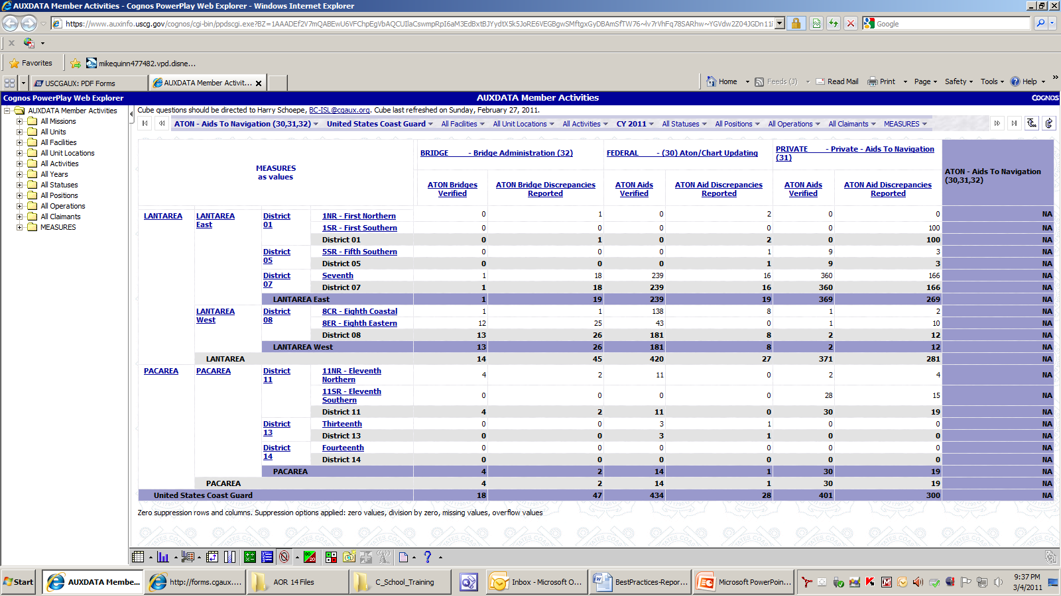

1. **IMPORTANT**: When reporting Navigation System mission activity, *each Auxiliarist must report their own individual activity*. Only one qualified AV should be recorded on a single 7030 AUXDATA Activity Report – Individual.
2. **Navigation System activity for a single aid or bridge should only be reported once by only one AV**.
   1. This example will explain the problem. Suppose two AV-qualified members go out on the same patrol and verify or check a total of 10 items together whether they are aids or bridges. The total number of items reported as AUXDATA activity should add up to a total of ten. Assuming the proper qualification, each member would submit an Individual 7030 report showing a portion of the ten items. Assigning 5 aids or bridges to each AV is considered fair. *Never assign 10 aids to each AV* because the subsequent AUXINFO report would erroneously show a total of 20 aids as being reported instead of a total of ten that were verified or checked on the patrol.
3. Fill in **LOCATION** of mission and **OPCON.**
   1. The Coast Guard is now tracking the different Operational Control (**OPCON**) centers. The OPCON is usually your local CG ANT or agency that is responsible for the aids or bridges in your Patrol Area. You should enter the unit’s OPCON number and not its name whenever possible. A Drop down menu, showing all of the Coast Guard OPCONs, is provided for this purpose. In the example below, the patrol was performed in Boston Harbor and the OPCON selected by menu is CG ANT Boston or 01-41949.



1. As an option for your own records, you may list the aids or bridges that you checked in the comments section and indicate if they were discrepant. This is not required nor is it recorded in AUXDATA.
2. For Chart Updating or **Coast Pilot** updates use mission code **41** and list the objects you checked in the comments section. This is an option and is not required. See the example on page 6.
3. Once you and your IS officer fully understand this process, you can submit multiple NS missions on the same 7030, taking 15 minutes or less each for each different mission 30, 31, 32 or 41. See the Example on the previous page.
   1. Be sure to match up the categories with the activity as described in Step #4.
4. **Reporting ATON Activity while on your own time-(Casual Observations)**
5. You can take AUXDATA time and activity credits if you casually perform NS activity while out on your boat or on foot on your own time. For example, you casually come upon an aid or bridge discrepancy while on a pleasure trip with your family.
6. See the 7030 example on page 3 for a practical example.
7. Prepare a 7030 AUXDATA Activity Report, Individual to report the ***TOTAL TIME*** that was spent on the mission. You can report your total time fully because you are not on an official patrol. The total time you report can include the time spent preparing reports that you submit to the Coast Guard and AUXDATA. You are allowed to take activity credit in AUXDATA for all the aids and bridges that you verify and check. Also, you are authorized to take credit for all photos submitted for the PATON records as Mission Code 31 as a PATON Watching Properly**.**
8. **Capturing all other ATON and NOAA activity on the 7029 form:**
9. Any other reportable Navigation Systems activity that you perform that you cannot categorize as mission 30, 31 or 32 is reported on your 7029 form under Mission Code **99B**.
10. Any other reportable work you do for NOAA that you cannot categorize under Mission Code 41 is reported on the 7029 form under Mission Code **99E**.

**Example of a 7029 Form**

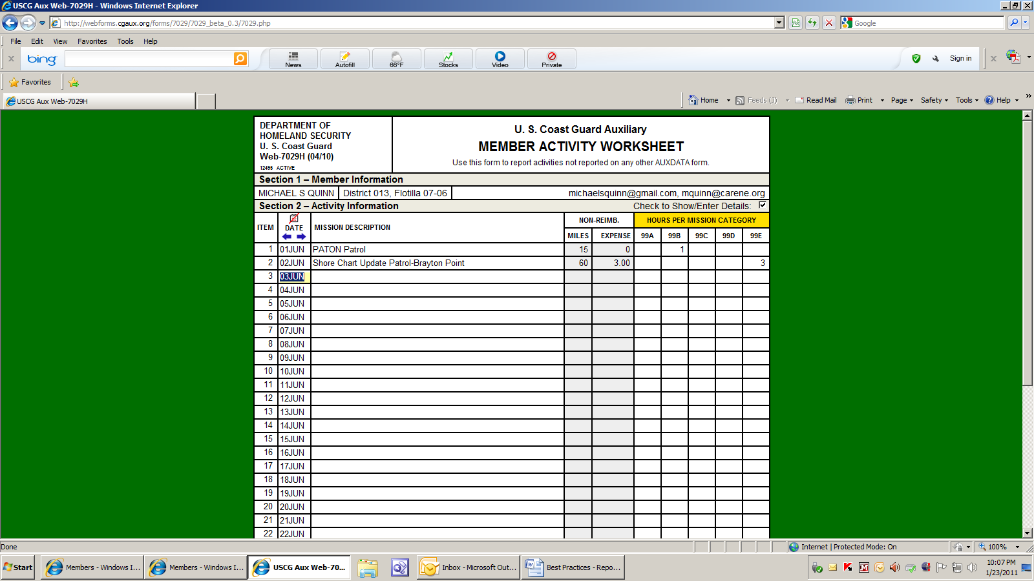

Any questions, feel free to contact:

Mike Quinn, ADSO-NS - 401-737-5078 - [michaelsquinn@gmail.com](mailto:michaelsquinn@gmail.com)

Frank Larkin- DSO-NS – 978-263-3023 – [FrankJLarkin@verizon.net](mailto:FrankJLarkin@verizon.net).