|  |  |
| --- | --- |
| cgauxlogo | Welcome to*First Northern**Navigation Systems* |
| PRIVATE Aids to Navigation Program | |

The Navigation System’s Private Aid to Navigation program (PATON) encourages the verification of every Private Aid to Navigation by AV qualified Auxiliarists during time periods (*Duration*) when these aids are deployed (*SET*) and for submitting professional on-line CG-705 PATON reports to the Coast Guard.

***Guidelines for the Private Aid - PATON Verification program . . .***

The emphasis on the AV program is on **prevention**, **accuracy, credibility, professionalism and service to the Coast Guard.** Our focus is directed toward building the recognition of each Auxiliary AV-Aid Verifier as a highly competent observer and reporter in the eyes of the Coast Guard. Guidelines for Aid Verifier qualifications have been established. These guidelines include the taking and reporting of fixes and depths, the pre-underway and on-scene evaluation of the electronic equipment being used, high quality on-scene observations, and professional on-line verification report preparation. Fixes are taken with GPS sets using WAAS, depths are corrected to the charted vertical datum, physical measurements, photographs, and the validation of observations to the Light List, the Coast Pilot and to the applicable NOAA Nautical Chart are included in the verification process.

***PATON training tools, forms and guides are provided*** for download to your home computer at www.uscgaan.com.

***NS-PN01* PATON PROGRAM HAND OUT**

Use this handout to promote the PATON - Private Aid to Navigation program with your Flotilla and Division members.

***NS-PN02* 33 CFR-CODE OF FEDERAL REGULATIONS**

A link is provided to this excerpt from the Code of Federal Regulations that is full of information about the various classes of Private Aids to Navigation, the specifications and rules governing private aids.

***NS-PN03* FIRST DISTRICT AID VERIFIER QUALIFICATION TRAINING PROGRAM**

This is a special AV Training Program section on the PATON Web Page where you will find the AV Qualification Guide and various PowerPoint training presentations that can be used for AV workshops and self-training exercises.

***NS-AN04*** **CG-7054 PATON** **REPORT**

Download this EXCEL form and keep copies in your NAV Kit for use when verifying Private Aids to Navigation.  This is also the best tool for documenting unauthorized Private aids.

***NS-PN05* PRIVATE AID TO NAVIGATION TRAINING**  This PowerPoint presentation depicts the various discrepancies that are commonly observed on Private Aids to Navigation.  Use it as an annual review for PATON Workshops and for training Aid Verifier Candidates.

***NS-PN06*** **PATON SYSTEM TRAINING GUIDE**

This guide provides the latest screen-by-screen information on the operation of the Web-Based PATON System (Harbormaster) used in First Northern.  It takes you through the initial registering process to the verification of the private aid and the report to the ANT Chief.  This is an on-line system that is accessed with your home personal computer.  The basic aids to navigation training programs found on the Federal Short Range Aid to Navigation Web Page are also part of AV-Aid Verifier training.  You will need an access code to use this system and you must be AV Qualified to perform verifications on private aids.

***NS-PN07* NON-PERMITTED PATON REPORT**

Use this form to report multiple non-permitted private aids. Note, that without the owner’s name and a means to contact the owner, the Coast Guard is at a loss to contact anyone to submit a permit application for the aid.

***NS-PN08* US COAST GUARD AID TO NAVIGATION MANUAL – CHAPTER 5 – Non Coast Guard Maintained Aids** Read this information about private aids as excerpted from the Coast Guard Aid to Navigation Manual.

***NS-PN09* ON SCENE OPERATION PRESENTATION 2020** This information about private aids deals with required activities when on-scene at the PATON. It is a great PowerPoint presentation for workshops before the start of the on-the-water activities.

***NS-PN11*** ***AUX-***[***7030***](http://forms.cgaux.org/email/a7030s.pdf) **ACTIVITY REPORT MISSION - INDIVIDUAL**

Use this on-line form to report your mission activity in order to receive Auxiliary recognition for your PATON work in AUXDATA. Use mission category 31 for PATONs and transmit your report to your IS Staff Officer.

The overall impact of the Auxiliary Private Aid to Navigation Program depends on this input to the AUXDATA System. Please take the time to make these important reports.

***CALL TO ACTION***

If the Private Aid to Navigation Program interests you, talk to your FSO-NS or SO-NS about becoming AV-Aid Verifier qualified. Upon qualification as an AV, you will be assigned specific PATONs to verify. After you have registered on the Web-Based PATON System (Harbormaster), you will be assigned an access code for the system for reporting via the on-line PATON system. Upon AV qualification, you will be providing vital information to the Coast Guard that helps update Federal documents and NOAA charts.

|  |
| --- |
| **EVERY AUXILIARIST, WHILE UNDERWAY ON AN AUXILIARY OPFAC SHOULD BE CHECKING AND REPORTING ALL DISCREPANCY(S) TO THEIR CG ANT ON EVERY FEDERAL AID, PRIVATE AID AND BRIDGE THAT THEY OBSERVE.  ALSO, THEY SHOULD BE CHECKING THE SHORELINE FOR CHARTED ERRORS OR OMISSIONS AND REPORTING THEM TO NOAA.** |

*All Auxiliarists are encouraged to contact their Navigation Systems Staff Officers to join their Division Auxiliary Navigation Systems Team and learn how they can make a real difference as a professional Aid Verifier.*

***Did you know*** *that there are over 5,000 Private Aids to Navigation within the First District which is estimated to be more than rest of the entire USA.*

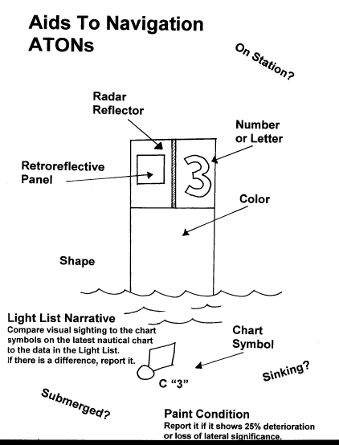

This an example of one of the many training aids provided on the Navigation Systems Web Site at [www.uscgaan.com](http://www.uscgaan.com)

Revision 2 – Prepared by the First District Northern Region Navigation Team. Direct your comments and questions to the DSO-NS at H 978-263-3023 – C 617-997-7423 – FrankJLarkin@verizon.net.