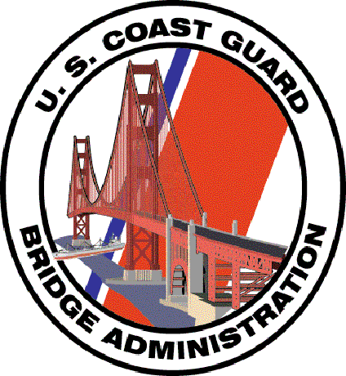

Welcome to the

First Northern

Bridge

Administration

Program

This Navigation Systems Division program encourages the checking of every Bridge by any Auxiliarist at any time. Nothing restricts any member from checking Bridges and reporting discrepancies to the Coast Guard. “Qualified Auxiliarists and their facilities are authorized assignment to duty to support and augment bridge surveys, investigate and provide information regarding waterways, safety and navigation situations pertaining to the bridge program, and provide direct assistance and support to the bridge program personnel. (Excerpted from Chapter 2, Section B4 of the Auxiliary Manual) A copy of the Bridge Program Memorandum of Understanding and Joint Action Plan of 29 February 1996 is available in Appendix A of the Auxiliary Manual.

1. The emphasis of the Bridge Checking Program is on accuracy, credibility, and professionalism, and is directed toward building the competence level of the Auxiliary in the eyes of Coast Guard Bridge Branch. There are guidelines for taking fixes and depths that require pre-underway and on-scene validation of all measuring equipment that you use, and for quality professional on-scene observation and on-line report preparation. This action can take the form of fixes taken with GPS sets using WAAS, depths corrected to the charted vertical datum, physical measurements, photographs and drawings, if necessary and the validation of your observations to the Light List, the Coast Pilot and a NOAA Nautical Chart. A revised reporting format has been developed that will further enhance the professionalism of the Bridge reports that the Coast Guard will receive from the Auxiliary.

2. Bridge Checking tools are provided for download to your home PC.

BAP01 – D1NR BRIDGE ADMINISTRATION PROGRAM ANNOUNCEMENT (03/02/08)– WORD – 2 pages. Use this handout to promote your Bridge Program to your members. It is also an image of the Bridge Web Page on the First Northern Aid to Navigation Web Site.

BAP02 – D1NR BRIDGE ADMINISTRATION PROGRAM STUDY GUIDE – WORD – 40 pages – This guide is full of illustrations and photos of the safety equipment discrepancies that are found on a bridge. The various light standards are fully illustrated. Many different pictures of bridge discrepancies are shown. The new guidelines for taking and reporting fixes and depths are explained in detail as well as the reporting of AN Activity to AUXDATA. This is a great training tool for introducing new members to the Bridge Program. This guide is currently in the process of development.

BAP03 – D1NR BRIDGE DISCREPANCY REPORT (03/02/08) – EXCEL – Use this form to record and report discrepancies observed on bridges. This report may be e-Mailed or mailed to the DSO-AN. The Bridge Database is also available for reporting bridge checks and discrepancies on-line.

BAP04 – D1NR HOW TO SAFETY CHECK A BRIDGE (03/02/08) – PowerPoint – This is a 155-slide presentation that explains all of the discrepancies that can occur with the safety equipment on a bridge. Use this tool for training new members about the Bridge Administration Program.
BAP05 – D1NR BACKGROUND INFORMATION ON BRIDGES (02/17/08) – PDF – 15 pages. This is a narrative on the rules governing the safety equipment on bridges. Use this narrative as a self-learning tool to increase your personal knowledge of Bridges. This is must reading for anyone active in the Auxiliary’s Bridge Administration Program.

BAP06 – D1NR WHAT TO LOOK FOR WHEN CHECKING A BRIDGE (03/05/08) – WORD – 4 pages. Use as a reference when on-scene checking a bridge. This is a great handout for Bridge Training Workshops.

BAP07 - BRIDGE DISCREPANCY REPORTING – PowerPoint – This presentation shows the various discrepancies that are found on a bridge. This is a work in process.

BAP08 - BRIDGE LIGHTING MANUAL – PowerPoint – Use this Coast Guard manual to expand your knowledge of the various lighting configurations that are found on a bridge. Normally, this presentation is used as a self-learning tool.

3. First Northern Bridge Database – Click here to access the First Northern Bridge Database.

4. If the Bridge Program interests you, talk to your Aid to Navigation Staff Officers. Every member of each Flotilla and Division is encouraged to check each Bridge that they pass while underway. There now is provision to take credit for your underway time and for your AN Activity in AUXDATA, whether or not you find a discrepancy on a Bridge. You can start contributing quality discrepancy reports to the Coast Guard in the time that it takes you to familiarize yourself with this program’s forms, guidelines and procedures.

Checking Bridges is a year-round Auxiliary program. You don’t always need a boat to participate in this program. New members are encouraged to join their local Auxiliary Aid to Navigation Teams. All we want is your skill, knowledge, and your desire to make a contribution to a worthy endeavor.

If every OPFAC included Bridge checking tasks on each of the scheduled patrols this year, we would make a large difference to the efficiency of the Coast Guard Auxiliary Bridge Administration Program. The Auxiliary support is mostly needed on the backwater channels and bays.

