United States Coast Guard Auxiliary
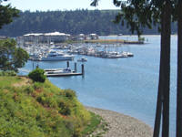
SC - SMALL-CRAFT FACILITY
Training Guide

TABLE OF CONTENTS

Introduction -2
SCF Study Guide Objectives – 2
Information on the SCF Program – 2
Visiting Small Craft Facilities – 2
Criteria for Visiting and Reporting a Small Craft Facility – 3
Small Craft Facility Listing for a Small Craft Chart – 4
Guidelines for Planning a Division or Flotilla Small Craft Facility Program - 5
Guideline for Visits to a Small Craft Facility Updating Visit - 5
Small Craft Facility Field Report Instructions – 6
Reporting Heading Data – 6
Reporting Chart Info – 7
Reporting the Facility Location – 7
Reporting Facility Availability – 7
Reporting Comments – 8
Reporting Facility Availability – 8
Attachments to your SCF Report – 9
Mailing Instructions – 9
Electronic Alternative Reporting – 9
NOAA Chart Ordering Rules – 10
SCF Report Rejection Process – 10
AUXDATA reporting - 10
Index - 11

INTRODUCTION:

An important part of the Auxiliary Chart Updating Program is SCF-Small-Craft Facility updating. Through this program, Auxiliarists can assist the National Oceanic and Atmospheric Administration (NOAA), National Ocean Service (NOS) in the accomplishment of this important mission. SCF activity involves the conducting of visits to marine facilities that service small craft that are located within the geographic area covered by a SC-Small Craft Chart, for the purpose of updating their services. These services are listed on SC-Small Craft Charts, in Coast Pilots and ENC-Electronic Nautical Charts. SC-Small Craft charts and publications contain information that is important to small craft operators and recreational mariners.

The definition of a small craft is a vessel sixty-five feet or less in length.

OBJECTIVES

1. To acquire a general knowledge of the responsibilities of Auxiliarists in the conduct of Small-Craft Facility Chart Updating activity.

2. To become familiar with the procedure for performing Small-Craft Facility Chart Updating activity and preparing reports for NOAA.

3. To be familiar with the procedure for reporting chart updating activity to AUXDATA.

INFORMATION ON THE SCF PROGRAM

The primary purpose for the Auxiliary’s participation in the Small-Craft Facility Updating program is specifically to assist the NOS-National Ocean Service with the checking of chart accuracy and with the updating of other NOAA publications.

Note that every Small Craft Facility presents the potential for a Facility Update, a Chart Update and a Coast Pilot Update. Review the chart for other chart update opportunities near the facility. Is the facility itself charted correctly? Review the Coast Pilot for references to the small craft facility. Are the facility’s services correctly stated? These are important questions when formulating a chart updating plan.

NOS/NOAA charts are listed in the Nautical Chart Catalog which is available free from your local chart sales agent. Also, there is a link to this document on the Navigation Systems Division Web Site at http://www.uscgaan.com. Among the charts listed in the National Chart catalogs are: Conventional Charts, Folio Small Craft Charts, Small-Craft (Pocket Fold) Charts, other Small-Craft Charts and Marine Facility Charts. Small Craft Charts are identified with the suffix “SC.”

Small Craft Charts and Marine Facility Charts are specifically designed to provide detailed information for Small Craft operators. Additionally, some large-scale conventional charts list the locations of marine facilities along with the services these facilities provide for the small boat operator. Much of the data received on a Small Craft Facility Update report are incorporated into ENC—Electronic Nautical Charts.

The term SCF-Small Craft Facilities refers to marinas, boat yards and those facilities that provide services for small-craft and are open to the public. These SCFs are normally found on NOS Small-Craft Charts for coastal waters / intracoastal waterways. However, other series of charts and documents show similar facilities including:
1) NOS Great Lake Charts (names only)
2) Coast Pilot

You should review the small-craft facilities found on all NOS charts in addition to those specifically mentioned above. While they may not qualify for a SCF Report, they may generate a NOAA Chart Update and/or a Coast Pilot updating opportunities.

VISITING SC FACILITIES
The easiest report to submit is the one for the marina where you keep your boat. Also, there are always opportunities to gather the information for a marina that you stop at while you are cruising. Frequently, PV-personal are used to visit SCF facilities and file SCF reports.

Do not interview Small Craft Facilities by telephone. An important part of the SCF procedure and report is the physical inspection of the facility as a validation for the SCF report. A manager’s business card or brochure is required as evidence of the existence of the facility.

CRITERIA FOR LISTING AND REPORTING A SMALL CRAFT FACILITY

Not all marine facilities will qualify as an official Small Craft Facility. Basic criteria have been established, without which a marine facility is ruled out, or if currently listed, can be disqualified and removed from Small Craft Facility lists. Note that information collected on marine facilities that do not meet the SCF criteria can still be reported as either a chart update or Coast Pilot update, or both.

Here are the basic qualifying criteria for a Small Craft Facility:

- The Small Craft Facility must be located within the limits of a Small Craft Chart.

  - If the facility is new or an update, NOAA will forward the appropriate information to the Coast Pilot staff. Do not report this same data as a Coast Pilot Update.

  - If the facility does not plot on a Small Craft Chart, do not submit it as a SCF report, but do submit the information as a Coast Pilot Update. Use a completed SCF Field Report as part of your evidence.

  - If the Small Craft Facility has been discontinued, report it as a SCF report only. Do not report the same data as a Coast Pilot Update. The Coast Pilot agency will be sent the appropriate information from NOAA and any information on this facility that is in the Coast Pilot will be removed.

- A small craft facility must be public (not private) and have, at a minimum, the following services:

Fuel sales to the public--Gasoline and / or Diesel.

A pump-out facility, or has access locally to a municipal or community pump-out facility. A municipally-managed pump-out facility located at a reasonable distance from the Small Craft Facility fulfills this requirement. Indicate the location (LAT/LON) of the municipal pump-out facility in the comments section of your report.

Transient berths and/or moorings. Transient means always available for a mariner who is traveling or making a temporary stopover.

3. The small craft facility must also have:

An approach depth. This refers to the navigable channel leading to the facility for a small craft to approach the facility.

An alongside depth. This means that there is sufficient water at the small craft facility’s dock or floats for mooring a small craft.

If the small craft facility fails to meet the above criteria, you may still report it:

- If it is currently listed on a small craft chart, report it as discontinuance.

- If it does not plot on a Small Craft Chart, submit the information as a Coast Pilot addition or update. Reference the section of Coast Pilot Reporting for the reporting procedure.

- Note, you may also survey the facility and report the details as a Chart Update.
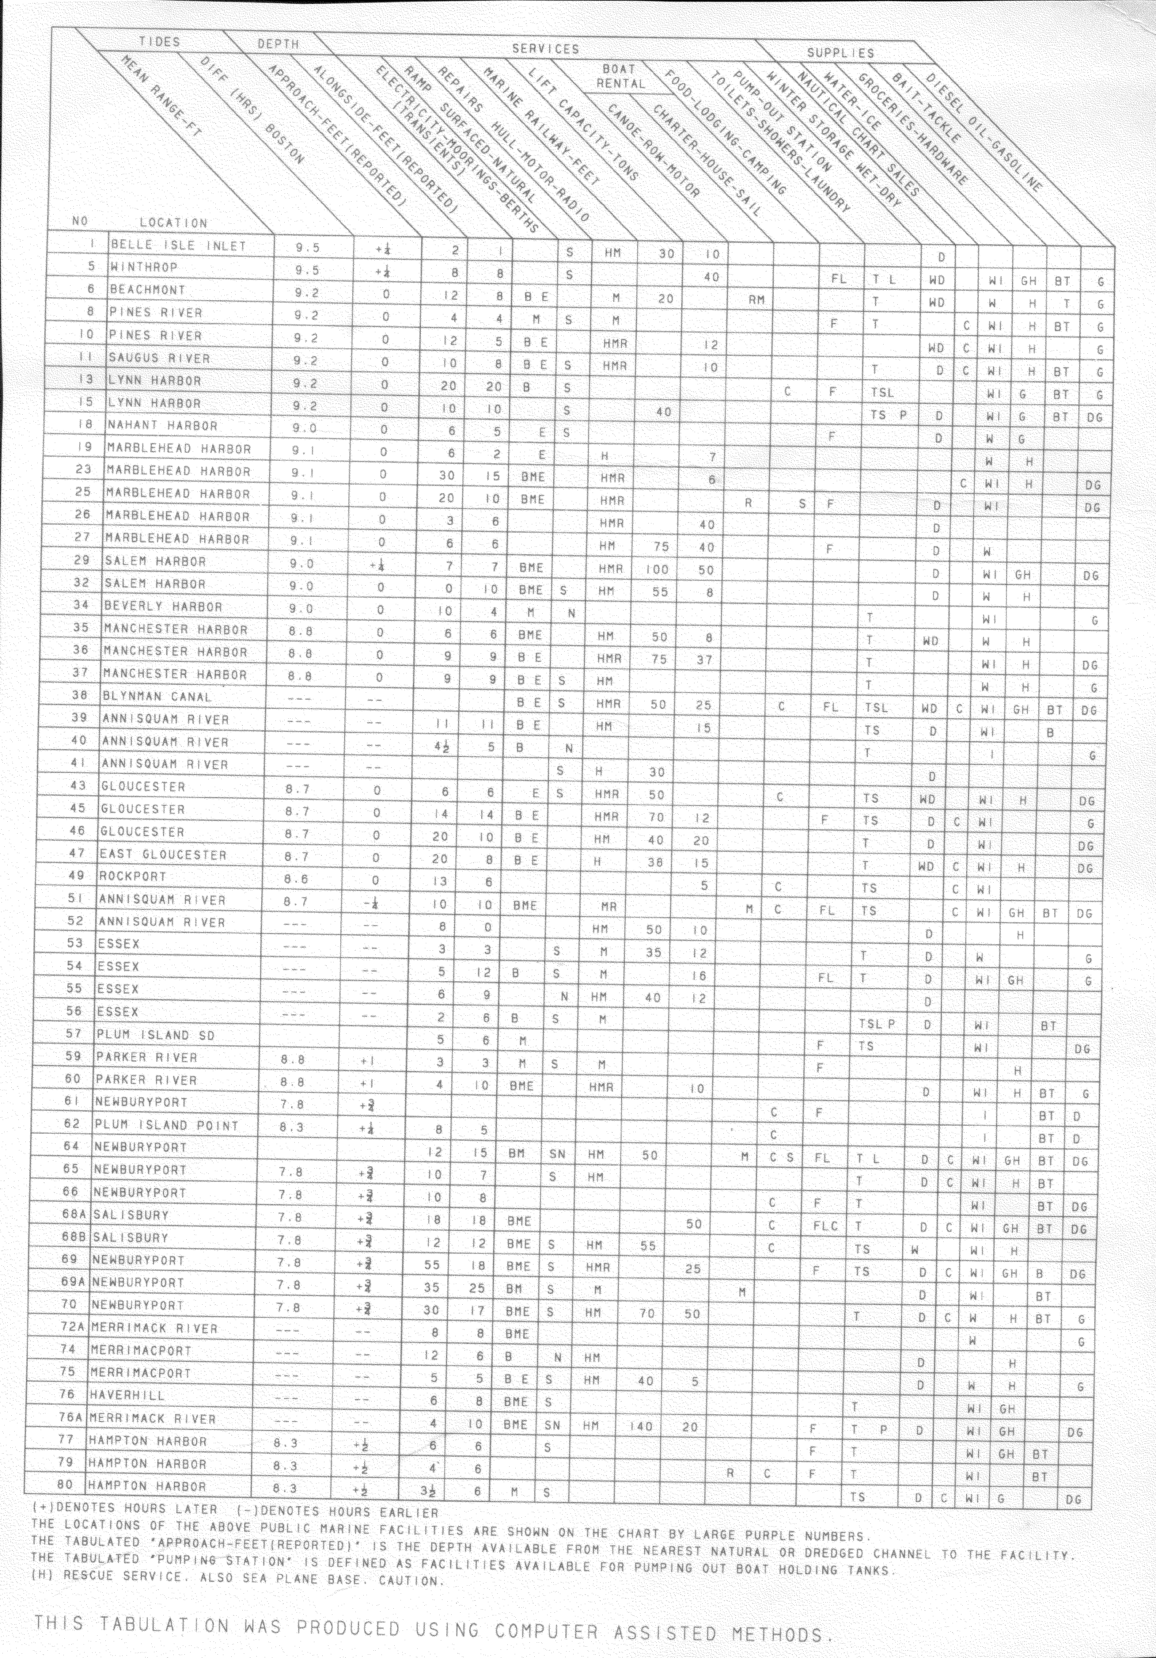
Small Craft Facility Listing from a Small Craft Chart

GUIDELINES FOR PLANNING A DIVISION OR FLOTILLA SMALL CRAFT FACILITY PROGRAM

- Establish a SCF-Small Craft Facility Planning Team within your Flotilla or Division.

- Survey all of the potential marine facilities within the chart and have them listed on a “Small Craft Facility Database.” This can be as simple as an EXCEL list resident on the District NS Web Site.

- Don’t miss any facilities. Make your list as complete as possible.

- This can be accomplished off-season using local almanacs and copies of Small Craft Charts and standard charts. Once you have identified a potential facility, search it out on the Internet for address and communication data.

- Review the Small Craft Facilities listed on the SC Chart and enter their official SCF number on their record in the database.

    - You now have identified the scope of your project for your Chart Updating Team(s).

    - Keep in mind that all of the facilities will not end up as official SCF reports. However, they are the potential Chart Updates reports and Coast Pilot Updates.

- Review the list of Auxiliary volunteers that you have trained to perform SCF Reports and assign them various facilities by entering their name in the SCF Database.

- Schedule SCF Update events. Provide extra copies of the NS-SC03 - Small Craft Facility Field Report forms for the participants. Updates can be performed by teams. If a chart update of the marine facility is appropriate, schedule extra time at the facility. You may want to put a Chart Updating Team into the facility as a separate event. Plan the activity around an Auxiliary fellowship event.

- After the field work is completed, the Division Chart Updating Team can reconvene and review the results.
- Decisions are made by the team members to finalize the appropriate reports for NOAA.

- The member who performs the on-scene interview or chart update should be listed on the “NS-SC03 - Small Craft Facility Field Report” as the reporter.

- Forward the completed reports to the DSO-NS with the required attachments for final review and submission to NOAA.

- Report time on a 7030 Activity Report Mission – Individual form using Mission code 41 to AUXDATA via the IS Staff Officer. It is not necessary to prepare this report when the activity was performed as part of an authorized NS Patrol. Your time underway will be reported by the Coxswain.

- Publish the results of your SCF program updates in your monthly reports and newsletters. This should help create interest in your program and add additional members to your team.

GUIDELINES FOR VISITS TO A SMALL CRAFT FACILITY

Small-Craft Facility activity may be performed using an operational facility as part of an ATON patrol or, on foot, as an Operational Support Mission (Mission Code 41). Generally, Auxiliary members prefer to conduct Small-Craft Facility activities as an ashore mission. Auxiliary members residing within close proximity of the marine facilities usually volunteer for these missions. Also, there is a natural tie in to the Auxiliary PV Program. Work with your FSO-PV or your SO-PV to become qualified.

PLEASE REPORT A SMALL CRAFT FACILITY ONLY IF THERE HAS BEEN CHANGES TO A PREVIOUSLY SUBMITTED SCF FIELD REPORT.

Performing a SCF visit is considered a public appearance as a representative of the Coast Guard Auxiliary. Therefore, an Auxiliary member must be in proper uniform and must always act in a professional manner and be knowledgeable about the procedure for verifying a Small Craft Facility.

- Make the owner/manager of the marine facility the focus of your visit.

- Introduce yourself and provide a clear explanation of the purpose of the visit.

- Explain that you are participating in an Auxiliary program to update the Small Craft Marine Facility information in support of NOS/NOAA charts and other publications.

- Demonstrate to the owner/manager how the information about marine facilities is presented to the general boating public on NOS/NOAA charts, Coast Pilots, ENC and other publications.

- Show the Small Craft listings in the Small Craft Chart for the area.

- Show the references made in the Coast Pilot regarding small craft facilities.

- Indicate that other almanacs pick up information from government publications for their own publications.

- Review the criteria necessary to become and retain official Small Craft Facility status.

- Practice prudence in answering any technical questions regarding Aids to Navigation and Chart Updating subjects not covered within the report form.

- Auxiliarists are not allowed to perform measurements or other technical activity regarding the data that is reported. Simply record the information that you receive as you receive it from the facility manager or POC—Person of Contact.

- If you cannot answer a technical or procedural question, discreetly refer the owner/operator to the nearest Coast Guard unit for an answer.

- If the question involves Small Craft Facility verifications, refer the question to your AN staff officer.

- Communicate back with the Small Craft Facility manager or person of contact (POC) when you obtain an answer to their question(s).

- NS staff officers should send copies of all questions to their DSO-NS who will prepare a “FAQ” publication that will become part of this procedure.

- Provide a close out summary of the visit to the facility manager / POC.

- Review the information that you received and recorded on the SCF Form.

- Express appreciation for the level of cooperation that was provided.

NS-SC03a - SMALL CRAFT FACILITY FIELD REPORT INSTRUCTIONS
This NS-SC03-SCF Field Report is available on the SCF Web Page on the Navigation Systems Division Web Site at: http://www.uscgaan.com. However, each field on this worksheet has pop-up instructions or a menu list in order to save you the bother and time for having to look up instructions in another document.

REPORTING HEADING DATA
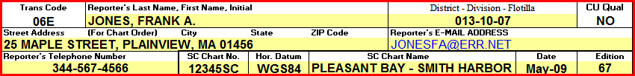

District – Select your three-digit District number from the drop-down menu.

Division - Enter your two-digit Division Number. (i.e., Division 3 would be shown as 03.)

Flotilla - Enter your two-digit Flotilla Number. (i.e., Flotilla 4 would be shown as 04).

Report Number – This field is reserved for use by the DSO-NS only. The report number is assigned by the DSO-NS after the quality assurance screen is performed on the SCF report.

Member ID No. - Enter your Auxiliary ID Number.

Last Name - Enter your first name.

First name and Initial - Enter your first name and initial.

Street Address - Enter your full address as specified.

E-Mail Address - Enter your E-Mail address.

Telephone Number - Home number – enter the telephone number where you can be reached during normal business hours. Also, enter your business phone number.

REPORTING CHART INFO

SC Chart Number - Enter the official number for the SC Chart as referenced in the chart’s General Information Box. Usually, chart numbers are referenced at the bottom left-hand corner of the NOAA chart.

SC Chart Name – Enter the official name for the chart you are reporting.

Horizontal Datum – Enter the horizontal datum from the chart that you use. This reference must be either NAD83 or WGS84. Charts with any other Horizontal DATUM may not be used for the Chart Updating program.

Date - Enter the Date of the chart. Normally, this data is listed at the bottom left-hand corner on the chart.

Edition - Enter the Edition of the chart. Normally, this data is listed at the bottom left-hand corner on the chart.

REPORTING THE LOCATION of the SC Facility

Geographical Location of the SC Facility – Enter charted name of the location where the SCF is located.

Latitude - Enter the latitude taken at the facility, formatted as dd-mm-ss.ss N.

Longitude - Enter the longitude taken at the facility formatted as ddd-mm-ss.ss W. Plot the LAT/LON on the chartlet that you attach to your report. This assists the NOAA cartographer to quickly ascertain the location of the facility.

Locating Method Used – Select the method used to take the fix from the drop-down menu.

EPE/HDOP – Select the type of quality control—either EPE-Estimated Position Error or HDOP-Horizontal Dilution of Position, from the drop-down menu.

QC Reading – Record the Quality Control reading n feet from your GPS Set.

TIME and DATE – Record the time and date of every FIX that you take, using the 24-hour clock, formatted as HHMM.

Date of Investigation - Enter the date when the facility owner (POC) was interviewed.

Time of Investigation - Enter the time of day when the facility owner (POC) was interviewed, using the 24-hour clock, formatted as HHMM.

REPORTING FACILITY Availability

Facility Availability – Select the availability from the drop-down menu--Annual (Open all year) or Seasonal (Open only on specific months).

Opens on: - If seasonal, show the month and date when the facility opens each year.

Closes on: - If seasonal, show the month and date when the facility closes each year.

Hours of Operation: - When open, indicate the hours when the facility is open for business, such as, 24 hrs, 0700 to 1100, etc. Use the 24 Hour Clock for time.

Days of Operation: - When open, indicate the days of the week when the facility is open for business, such as, 7 days, M thru F, etc.

Access to the Facility via land - Show any nearby major Federal or State Routes used to gain access to this facility by land vehicle.

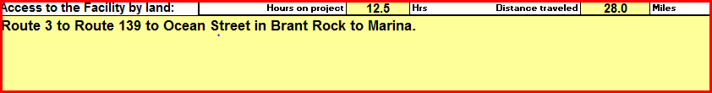

Hours on project: - Enter the total number of hours that you spent on all aspects of accumulating evidence , traveling, making observations, interviewing, and preparing your final report. This data is used to calculate the award of credits for your report by NOAA.

Distance traveled: Enter the total number of miles traveled on all aspects of accumulating evidence , traveling, making observations, interviewing, and preparing your final report. This data is used to calculate the award of credits for your report by NOAA.

COMMENTS
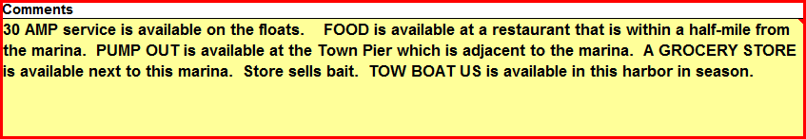
Enter any comments necessary to clarify your entries above. Many fields on the worksheet call for additional data and explanation. This is the location where this data is reported. Always reference the field name for which the data is being provided.

REPORTING FACILITY DATA

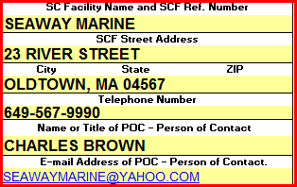 | SC Facility Name and Number - This field is required on Facility Update and Discontinue a Facility reports. Take the number from the SC Chart. Take the facility name from the SC Chart. If a new report, use the corporate name for the facility.  Facility Address - Required field. Enter the official mailing address for the facility and the City, State, and Zip Code. Enter the address data as specified.

Business Phone - Required field. Enter the phone number that is covered during normal business hours.

Person of Contact-POC - Required field. Report the owner or the manager. This is a good time to ask for a business card or SCF brochure.

E-Mail Address - Enter the E-mail address for the POC.

Web Site - Enter the SCF’s web site address in the Comments section, if available.

REPORTING FACILITY SPECIFICATIONS
Action - Check one box to define whether this report is a:  New– Facility is not currently listed on a Small Craft Chart.  Update – Facility is currently listed on a SC Chart and has an assigned SCF reference number.  Discontinue – Facility is currently listed on a SC Chart but does not meet the criteria for a SCF.  SCF is a public facility. - Required/Criteria Field. YES / NO. If NO is selected, this facility cannot become a SCF. If it currently exists on a SC Chart, change the Action Code to “Discontinue.” | 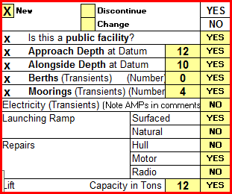

Approach Depth at DATUM - Required/Criteria Field. YES / NO. If NO is selected, this facility cannot become a SCF. If the facility currently exists on a SC Chart, change the report’s Action to “Discontinue.” Depth should be obtained from the POC-Person of Contact. Do not attempt to measure and report this depth on your own. Depth should be corrected to local chart’s vertical Datum. This depth figure should represent the controlling depth for the dredged channel to the facility.

Alongside Depth at Datum - Required/Criteria Field. YES / NO. If NO is selected, this facility cannot become a SCF. If the facility currently exists on a SC Chart, change the Action Code to “Discontinue.” Depth should be obtained from the POC. Do not attempt to measure and report this depth on your own. Depth should be corrected to local chart’s vertical Datum.

Berths – transient - Required/Criteria Field. YES / NO. If NO is selected and “Moorings – transient” is also answered with a “NO,” this facility cannot become a SCF. Transient berths are rented on a day-to-day basis. List the number of transient berths available.

Moorings – transient - Required/Criteria Field. YES / NO. If NO is selected and “Berths – transient” is also answered with a “NO,” this facility cannot become a SCF. Transient moorings are rented on a day-to-day basis. List only the number of transient berths available.

Electricity - YES / NO. If YES, indicate the amperage available in the comments section of this report. This refers to service to transient boaters only.

Launching Ramp - YES / NO. Show whether the ramp surface is natural or surfaced.

Repairs - YES / NO. Show the type of repairs performed at this facility—Hull, Engine, and/or Radio, etc.

Lift Capacity - YES / NO. Show the lift capacity in Tons. Indicate the type of lift in the comments section of this report. If a major lift, submit photos with your report.
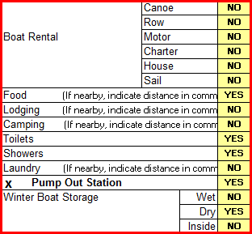 | Boat Rental - YES / NO. Show the type of boat rental that is available—Canoe, Row, Motor, Charter, House, and/or Sail. Attach a copy of the rental company’s brochure as evidence.  Food - YES / NO. If the store is not on the premises, indicate the distance in the comments section of this report. If a restaurant, try to attach a copy of the restaurant’s brochure as evidence.  Lodging - YES / NO. If the hotel or inn is not on the premises, indicate the distance to it in the comments section of this report. Try to obtain a brochure from the lodging as evidence.  Camping - YES / NO. If the camp site is not on the premises, indicate the distance to it in the comments section of this report. Try to get a brochure from the camp facility as evidence.

Toilets - YES / NO.

Showers - YES / NO.

Laundry - YES / NO. If the laundry is not on the premises, indicate the distance to it in the comments section of this report.

Pump Out Station - Required/Criteria Field. YES / NO. If NO is selected, this facility cannot become a SCF. If the facility currently exists on a SC Chart, change the Action Code to discontinue. SCF must have a pump-out facility or have access to a municipality or community facility. Show the latitude and longitude of the pump out facility if not at the SCF location. If the pump out service is provided by boat, indicate the phone number or radio channel that the service monitors in the comments section.

Winter Boat Storage – Wet – Dry – Inside - YES / NO.
Wet storage is in the water. Dry storage is not in the water. Inside storage is in a building, out of the weather. Try to obtain a document that explains the storage availability as evidence.

Nautical Chart Sales - YES / NO.  Water - YES / NO. Is fresh water available for transient slips or to the public?  Ice - YES / NO. Available for sale to transient mariners.  Groceries - YES / NO. Available for sale. If the groceries are not sold on the premises, indicate the distance to the store in the comments section of this report.  Hardware - YES / NO. Available for sale. If the hardware is not sold on the premises, indicate the distance to the hardware store in the comments section of this report. | 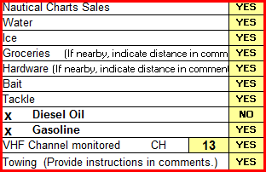

Bait - YES / NO. Available for sale. If the bait is not sold on the premises, indicate the distance to the bait store in the comments section of this report.

Tackle - YES / NO. Available for sale. If the tackle is not sold on the premises, indicate the distance to the tackle store in the comments section of this report.

Diesel Oil - Required/Criteria Field. YES / NO. If NO is selected and if “Gasoline” below is also answered with a “NO,” this facility cannot become a SCF. If the facility currently exists on a SC Chart, change the Action Code to discontinue. SCF must have a fuel capability of Diesel or Gasoline.

Gasoline - Required/Criteria Field. YES / NO. If NO is selected and “Diesel Oil” above is also answered with a “NO,” this facility cannot become a SCF. If the facility currently exists on a SC Chart, change the Action Code to discontinue. SCF must have a fuel capability of Diesel or Gasoline.

VHF Channel monitored. - YES / NO. If YES, indicate the specific VHF channel that is monitored by this facility.

Towing - YES / NO. If YES, provide instructions in the Comments section for getting in touch with the available towing. Include a brochure from the towing company if available.

RECOMMENDATION
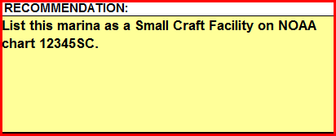
Make a recommendation to NOAA based on your observations and evidence presented.

ATTACHMENTS TO YOUR SCF FIELD REPORT

Note that some of these attachments are required. SCF reports submitted without them will be rejected back to the reporting Auxiliarist and not be forwarded to NOAA.
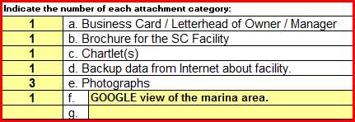

Business Card - This is a required attachment. Attach a business card from the facility owner or POC. This adds credibility to your report. Indicate the number of cards attached on your SCF Field Report. If a business card is not available, a copy of the business letterhead or a brochure will suffice. This is added evidence of the existence of the facility.

Brochure for facility - If available, attach a brochure for the facility or for any of the special facilities at or near the facility. Indicate the number of brochures that you attach to your report. This is a desirable attachment but not required.

Chartlet - This is a required attachment. Attach a chartlet showing the location of the facility. You can also submit a layout of the facility with LAT/LON as a Chart Update. The SCF’s location (FIX) should be plotted on the chartlet. Photo copies of the section of the chart with the plotted facility are acceptable. The chartlet must be taken from the Nautical Chart number and version for the Nautical Chart that is entered in the heading section of your report.

Photographs - Indicate the number of photos attached to this report. Photos are highly desirable but are not usually needed
SCF03 – SMALL CRAFT FACILITY FIELD REPORT MAILING INSTRUCTIONS:
Staple all of the required attachments at the top left-hand corner of the USCGAUX SCF Worksheet in the following order:
a. Business card(s).
b. Brochure(s) of the SC Facility and/or nearby facilities.
c. Chartlet(s).
d. Data from the Internet about the SCF.
e. Photographs.
f. Other attachments.

and mail to your:

DSO-NS or District SCF Program designate.

Always keep a copy for your own records.

NOAA CHART ORDERING RULES
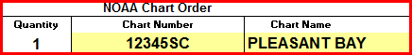
A copy of the NOAA Chart may be ordered on the SCF form when the following conditions exist:

- A section or copy of a SC nautical chart and other required attachments are included with the SCF Report.

- The SCF-Small Craft Facility meets all of the criteria for a legitimate Small Craft Facility.

- The SCF report is professionally prepared, complete and acceptable to NOAA.

AUX / NOAA SCF FIELD REPORT QUALITY CHECK AND REJECTION PROCESS

The DSO-AN or designate will review all Small Craft Facility Field Report submissions. Incomplete reports and reports submitted without the proper attachments will be returned to the reporter for correction and resubmission. Or, you may receive an e-mail requesting additional data.

In addition, NOAA will return all the copies of rejected SCF Field Reports to the DVC-MN who will notify the appropriate DSO-NS of the problem(s) noted by NOAA.

This activity is not meant to be punitive but more in the spirit of a learning exercise so that the Auxiliary observer/reporter will learn to submit correct reports in the future. This also keeps us abreast of data that NOAA no longer needs and now wants. This also generates updates to the NS-SC02-Small Craft Facility Training Guide.

AUXDATA Reporting

When Small Craft Facility reporting is performed as part of an authorized operational patrol, your time for the SCF activity is reported as part of the patrol to POMS. No additional reports are made to AUXDATA.

When Small Craft Facility reporting is performed without formal orders, report your time as a Mission Code 41 on a 7030 Activity Report Mission – Individual (CI) form. Also include your time to prepare and mail the NS-SC03 Small Craft Facility Field Report.

NOAA awards credits for all SCF Field Reports that they accept as useable. See below:

===============================================================
NOAA Credits awards for SC - Small Craft Facility Field Reports

- For each SC facility reported per the guidelines in the NS-SC02 SCF Training Guide on a NS-SC03 Small Craft Facility Field Report, 20 credits will be awarded.

- Additional credit awards for SC reports:

Time – 6 credits awarded per hour reported and accepted by NOAA for the time expended planning, observing and reporting the SCF activity.

Distance – 1 credit awarded per mile reported and accepted by NOAA for the miles traveled while planning, observing and reporting SCF activity.

Supporting Documentation – 6 credits will be awarded per attached NS-SC03 Small Craft Facility Field Report and supporting document(s).
===============================================================

INDEX

Alongside Depth – 3.
ANSC7030 – Activity Report Mission – Individual – 5.
Approach Depth – 3.
AUXDATA – 2, 11.
Bait – 9.
Boat Rental – 8.
Berths – 8.
Brochures - 10.
Business Cards – 10.
Camping – 9.
Chartlets – 10.
Charts, ordering – 10.
Chart Updates – 5.
Chart Sales – 9.
Coast Pilot – 2, 3, 5, 6.
Criteria for reporting – 3.
Diesel – 9.
Division Chart Updating Team – 5.
Electricity – 8.
ENC – Electronic Nautical Chart – 2, 6.
Food – 9.
Gasoline – 9.
Groceries – 9.
Hardware – 9.
Ice – 9.
Internet attachments – 10.
Launching Ramp – 8.
Laundry – 9.
Lodging – 9.
Mooring 8.
Nautical Chart Catalog – 2.
Navigation Systems Division Web Site – 2.
NOAA – 2, 11.
NOS Charts – 2, 6.
NS-SCF03 – Small Craft Facility Field Report – 5.
Photographs – 10.
Pump-out Station – 9.
Report attachments - 10.
SC-Small Craft Chart – 2, 3, 6.
Showers – 9.
Small Craft Facility Database – 5.
Small Craft Facility Listing – 4.
Storage – 9.
Tackle – 9.
Toilets – 9.
Towing – 10.
VHF Radio Channel – 10.
Visiting Small Craft Facilities – 2.
Water – 9.

