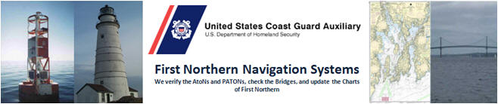

Standard deviation from permitted location:

25ft – Fixed Aid

50ft – Floating Lateral Aid

500ft – All other aids

Standard accuracy Statements:

Note: Change text in yellow for your specific area.

Aid is charted and in the Light List. Aid was 39.36 feet bearing 131 degrees True from permitted location which is within the 500 watch circle of a regulatory aid. Aid is permitted for Quick flashing but actually is flashing with a 4 second period.

Aid was 4617 feet bearing 331 degrees True from permitted location which is outside the limit of a 500 foot watch circle of a regulatory aid. Aid's permitted position plots in the middle of Mt Hope Bay approach channel.

1. A Garmin GPS 78S with WAAS enabled, operating in 3D Differential was used to fix the aid. Pre-underway accuracy was checked at the dock against a known location. 2. A Garmin 740S echo sounder was used to take the depth. Pre-underway accuracy was checked at the dock with a hand-held echo sounder. Correction for the transducer is 1.3 feet. The on-scene Substation was Prudence Island on Newport. 3. The reported fix and depth were taken approximately 3' 10" up wind and upstream from the PATON to offset the effect of the aid’s watch circle.

